Water resource insecurity in Morocco
Use the PowerPoint presentation or the internet to help you with the following activities.
- The street art in Figure 1 is a depiction of water insecurity.
Figure 1 Water insecurity
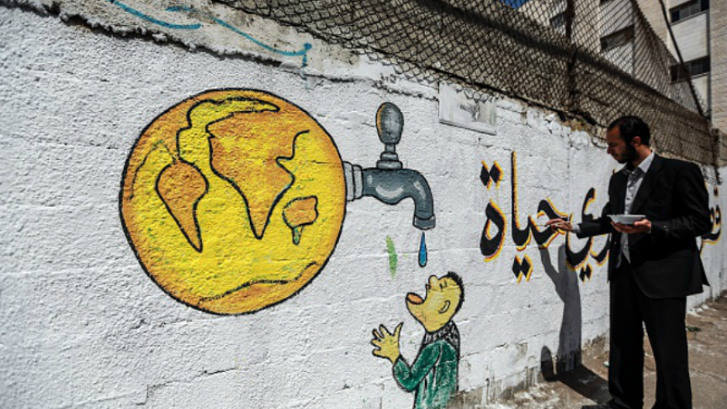
Write your own definition of water security including the following words ‘reliable’, quantity’ and ‘quality’.
----------------------------------------------------------------------------------------------------------------------------------------------------------------------------------------------------------------------------------------------------------------------------
- Figure 2 shows water insecurity (water stress) in the Middle East and North Africa.
Figure 2 Water insecurity in the Middle East and North Africa
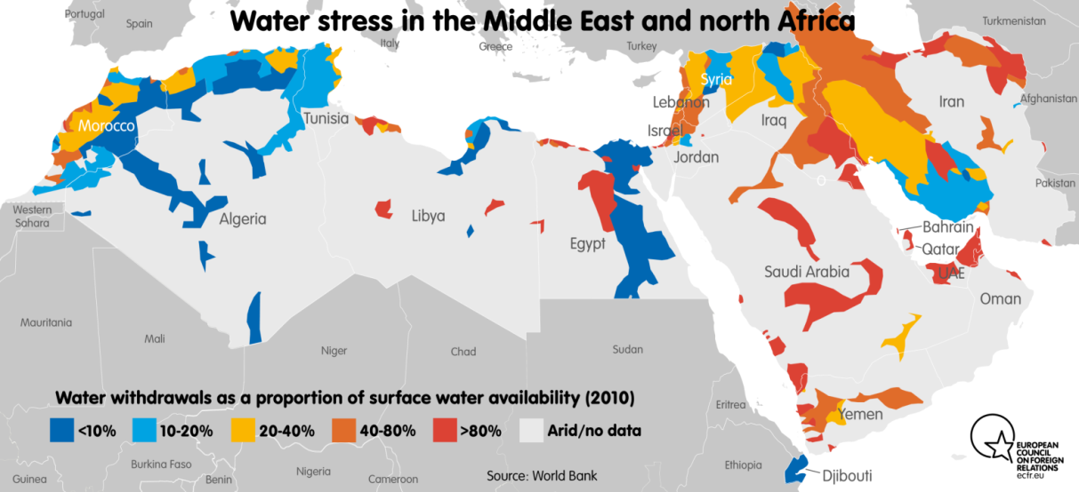
- Identify three countries experiencing severe water stress (>80%).
-------------------------------------------------------------------------------------------------------------------------------------
- Describe the pattern of water stress across the Middle East and North Africa.
------------------------------------------------------------------------------------------------------------------------------------------------------------------------------------------------------------------------------------------------------------------------------------------------------------------------------------------------------------------------------------------------------------------
- Suggest why there are several areas of severe water stress on the north coast of Africa.
----------------------------------------------------------------------------------------------------------------------------------------------------------------------------------------------------------------------------------------------------------------------------
- Figure 3 is an expanded view of water insecurity (stress) in Morocco. The same colour key applies as in Figure 2.
Figure 3 Water insecurity in Morocco
- Use the internet to find an atlas map of Morocco. Locate and label the following urban areas (with high water demand): Rabat, Casablanca, Safi, Essaouira, Agadir, Marrakech and Ouarzazate
- Locate and label the Sahara Desert, the Atlas Mountains and Algeria
- Describe and suggest reasons for the variations of water security in Morocco.
--------------------------------------------------------------------------------------------------------------------------------------------------------------------------------------------------------------------------------------------------------------------------------------------------------------------------------------------------------------------------------------------------------------------------------------------------------------------------------------------------------------------------------------------------------
- Figure 4 shows water protests in Zagora in 2017. Zagora is a town in the Draa Valley on the northern fringe of the Sahara Desert.
Figure 4 Water protests in Zagora, 2017
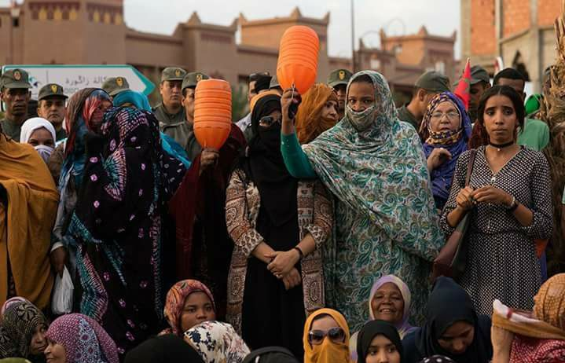
- Notice that most of the protesters are women. Suggest why this is the case.
--------------------------------------------------------------------------------------------------------------------------------------
- What is the evidence that this protest is being controlled?
--------------------------------------------------------------------------------------------------------------------------------------
- Zagora is located at the edge of the Sahara Desert. Suggest how population growth, tourism and commercial agriculture have contributed to domestic water shortages.
Population growth
----------------------------------------------------------------------------------------------------------------------------------------------------------------------------------------------------------------------------------------------------------------------------
Tourism
----------------------------------------------------------------------------------------------------------------------------------------------------------------------------------------------------------------------------------------------------------------------------
Commercial agriculture
----------------------------------------------------------------------------------------------------------------------------------------------------------------------------------------------------------------------------------------------------------------------------
- Much of Morocco’s water supply comes from a combination of stored surface water and underground water (groundwater) fed primarily by the Atlas Mountains (Figure 5).
Figure 5 The Atlas Mountains – an important source of Morocco’s water
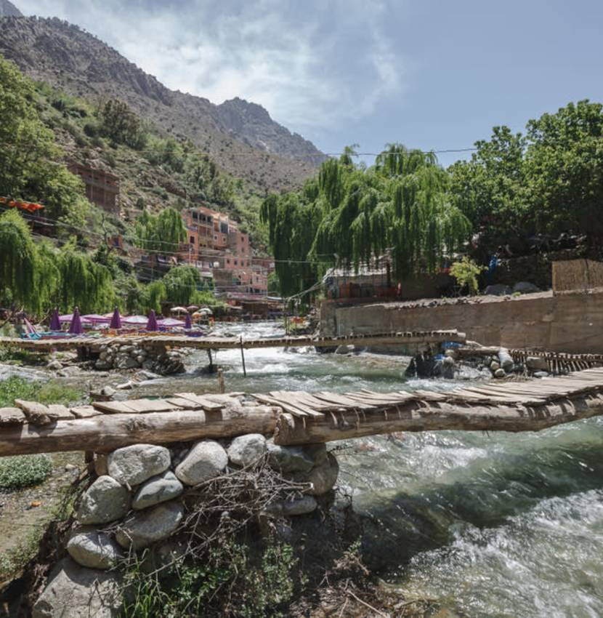
- Identify three factors that have made it difficult to maintain a reliable supply of water.
------------------------------------------------------------------------------------------------------------------------------------------------------------------------------------------------------------------------------------------------------------------------------------------------------------------------------------------------------------------------------------------------------------------
- Identify the three broad strategies to improve water supplies proposed by the Moroccan government in the National Drinking Water Supply and Irrigation Programme (2020-2027).
------------------------------------------------------------------------------------------------------------------------------------------------------------------------------------------------------------------------------------------------------------------------------------------------------------------------------------------------------------------------------------------------------------------
- Suggest why the Atlas Mountains is a major source of water.
--------------------------------------------------------------------------------------------------------------------------------------------------------------------------------------------------------------------------------------------------------------------------------------------------------------------------------------------------------------------------------------------------------------------------------------------------------------------------------------------------------------------------------------------------------
- Dams and reservoirs (Figure 6) are important sources of water.
Figure 6 Mohammed V multi-purpose dam
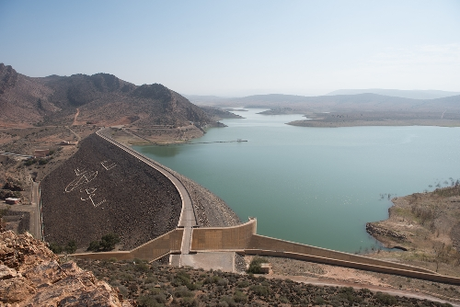
- Use Figure 6 to suggest some problems associated with dam and reservoir construction in Morocco.
--------------------------------------------------------------------------------------------------------------------------------------------------------------------------------------------------------------------------------------------------------------------------------------------------------------------------------------------------------------------------------------------------------------------------------------------------------------------------------------------------------------------------------------------------------
- Figure 7 shows the newly constructed Zerrar water dam near Essaouira. Add text boxes alongside the photo to describe some of the characteristics of the project.
Figure 7 Zarrar water dam

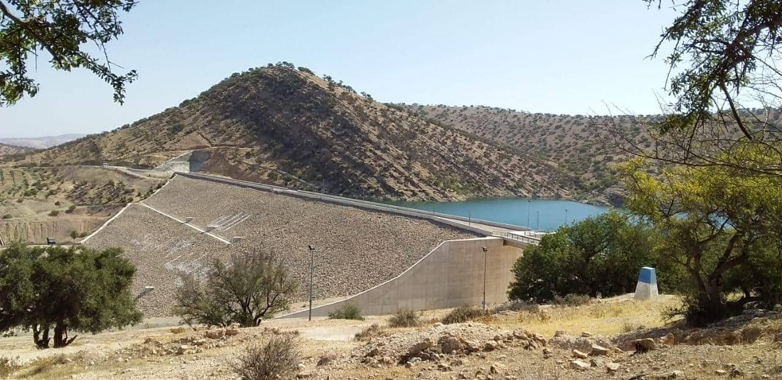
- A major desalination plant is being constructed at Agadir to convert seawater into freshwater using electricity generated by a nearby wind farm. Use the information below together with the Powerpoint presentation and your own internet research to write a short case study about the Agadir desalination power plant.
Figure 8 Desalination using the reverse osmosis process
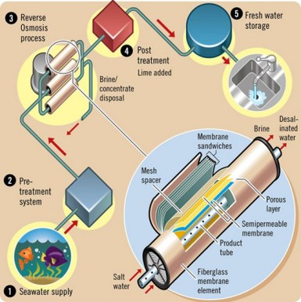
https://waterenergymatters.wordpress.com/2012/12/09/desalination-part-ii-a-relatively-short-primer-on-the-technology/
The project entails an offshore intake connected to two pipes that will convey the water to the desalination plant. It will also be accompanied by reservoirs for storing drinking water, at least five pumping stations, 22km of pipelines and about 490km of distribution network. The desalination plant will run on electricity from a wind farm and have a daily capacity of 275,000 m³, expandable to 450,000m³ per day.
At least 150,000m³ of water will thus be transported daily to Greater Agadir, including the city and the territory. In order to reduce the plant’s electricity consumption, a pressure exchanger system will be installed. This will allow energy to be recovered and has a very positive impact on the cost of energy, which is reduced by about 43% per cubic metre produced. Upon completion, part of the treated water will be used to supply an irrigation system in the Chtouka plain.
https://constructionreviewonline.com/news/egypt/construction-of-agadir-desalination-project-in-morocco-on-track/

