Hot Deserts: an introduction
Use the PowerPoint presentation or the internet to help you with the following activities.
- On Figure 1 label the Atlas Mountains and the Sahara Desert.
Figure 1 Rainfall in Morocco
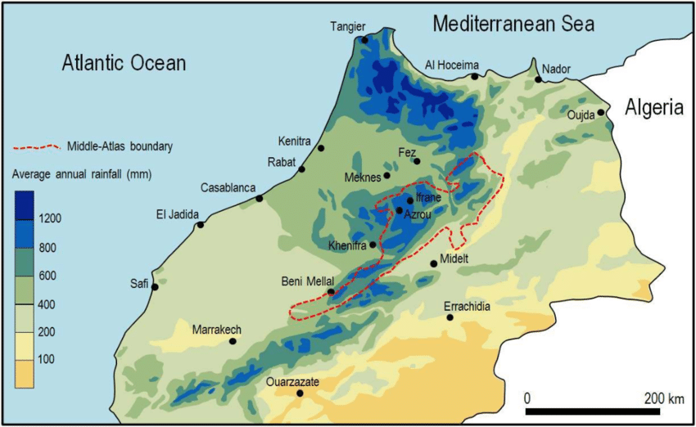
https://www.researchgate.net/figure/Spatial-distribution-of-average-annual-rainfall-1961-1990-in-northern-Morocco_fig1_324695640
- Describe the pattern of rainfall in Morocco.
------------------------------------------------------------------------------------------------------------------------------------------------------------------------------------------------------------------------------------------------------------------------------------------------------------------------------------------------------------------------------------------------------------------------------------------------------------------------------------------------------------------------------------------------------------------------------------------------------------------------------------------------------------------------------------------------------------------------------------------------------------------------------------------------------------------------------------------------------------------------------------------------------------------------------------------------------------------------------------------------------------------------------------------------------------------------------------------------------------------------------------------------------------------------------------------------------------------------------------------------------
- Figure 2 below shows a typical desert landscape in Morocco.
- What name is given to a bare, rocky desert such as this? _________________________
- What type of desert is known as ‘erg’? ________________________________________
- What name is given to the angular fragments of rock? ____________________________
- What process is responsible for their angular shape? _____________________________
- Suggest evidence that water occasionally flows over the land (what’s missing?).
----------------------------------------------------------------------------------------------------------------------------------------------------------------------------------------------------------------------------------------------------------------------------Figure 2 Typical desert in Morocco
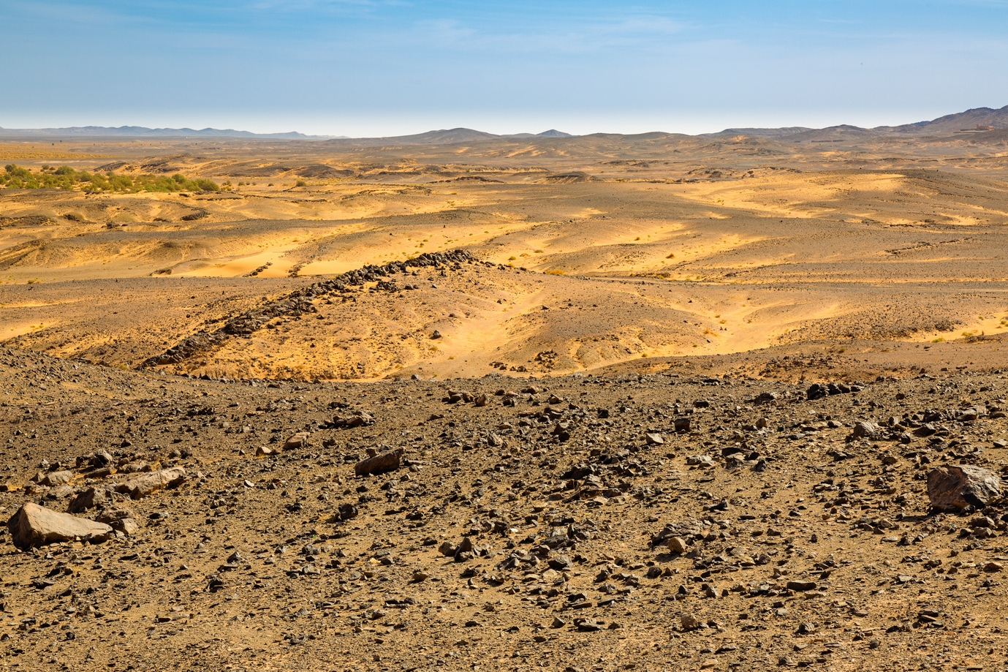
- Look at Figure 2. Notice that there are a few trees in the far distance. Suggest why these trees are growing in such an arid (dry) landscape.
------------------------------------------------------------------------------------------------------------------------------------------------------------------------------------------------------------------------------------------------------------------------------------------------------------------------------------------------------------------------------------------------------------------
- Look at Figure 3, which shows the world’s hot deserts.
- Use an atlas or the internet to label the following deserts on the map.
- Atacama
- Mojave
- Thar
- Gobi
- Arabian
- Locate and label Morocco.
Figure 3 The world’s hot deserts
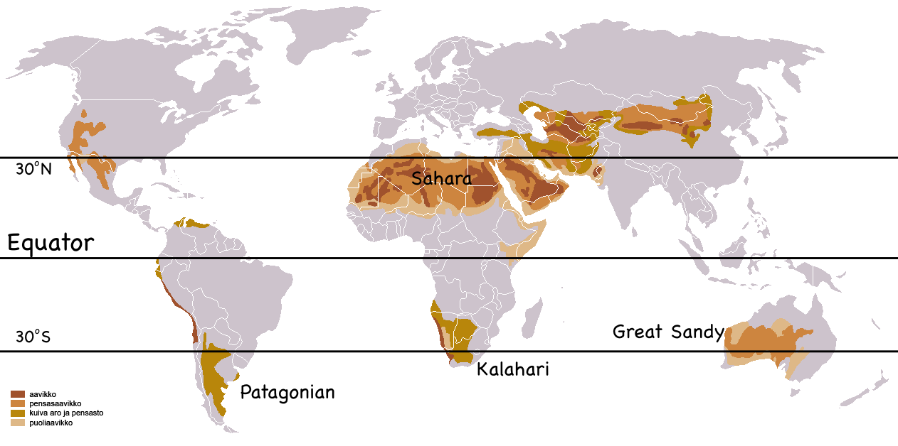
https://montessorimuddle.org/2011/04/21/global-atmospheric-circulation-and-biomes/
- Annotate Figure 4 below to explain why hot deserts are arid (dry).
Figure 4 Atmospheric circulation and location of hot deserts
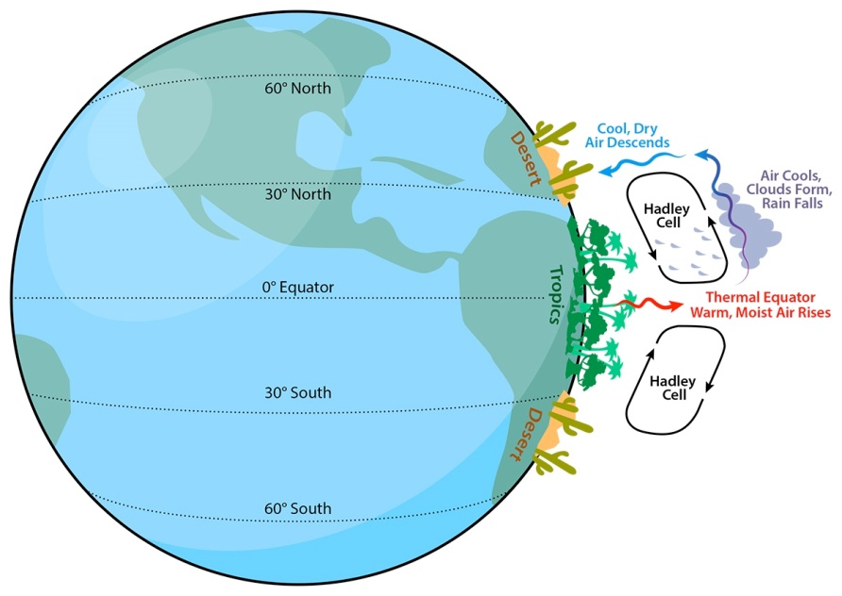(https://askabiologist.asu.edu/explore/desert)
- Figure 5 provides climate data for Ouarzazate, a town on the southern side of the Atlas Mountains and on the northern edge of the Sahara Desert (Figure 1).
- What is the highest average maximum temperature? ____ °C Month: ____________
- Calculate the TOTAL ANNUAL RAINFALL _______ mm
Figure 5 Climate data for Ouarzazate, Morocco
 | J | F | M | A | M | J | J | A | S | O | N | D
Annual average maximum temperature (°C) | 18 | 20 | 23 | 27 | 31 | 36 | 40 | 39 | 34 | 27 | 22 | 17
Annual average minimum temperature (°C) | 1 | 3 | 6 | 9 | 12 | 17 | 20 | 20 | 16 | 11 | 7 | 2
Annual average rainfall (mm) | 16 | 12 | 14 | 11 | 10 | 3 | 1 | 5 | 12 | 24 | 25 | 17

Use the climate data in Figure 5 to construct a climate graph using the graph axes below.
- Temperature – plot points midway in each month and join with a freehand line
- Rainfall – draw bars to represent the rainfall data
- Label (or use a colour key) the temperature lines and rainfall bars

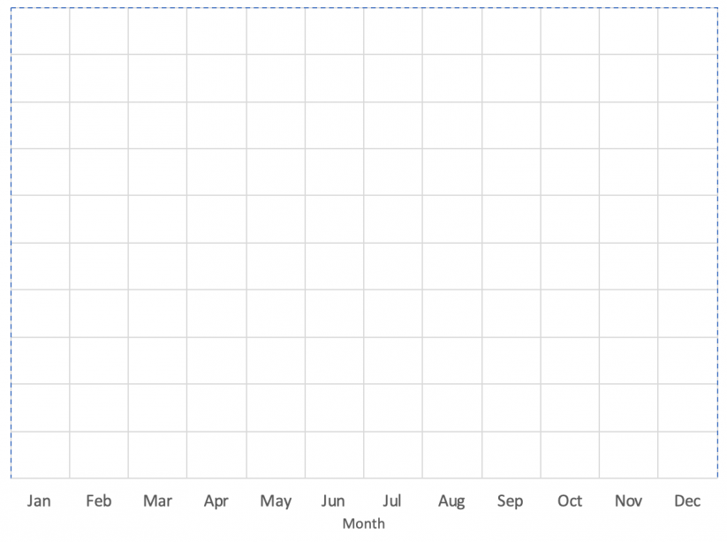
30
Rain (mm)
20
10
Temp. (°C)
40
10
20
30
- What is the climatic evidence that Ouarzazate is located in a hot desert?
----------------------------------------------------------------------------------------------------------------------------------------------------------------------------------------------------------------------------------------------------------------------------

