Opportunities and challenges for development: the Draa valley
Use the PowerPoint presentation or the internet to help you with the following activities.
- Figure 1 shows the major rivers in Morocco.
Figure 1 The major rivers in Morocco
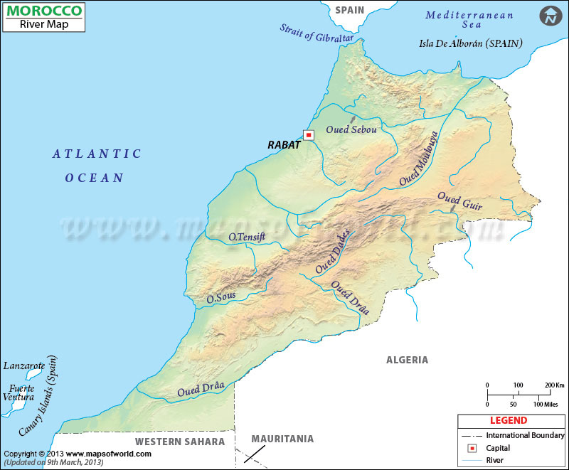
- Label the High Atlas mountain range.
- Use a highlight pen to highlight the course of the Oued (River) Draa.
- Locate and label Ouarzazate.
- Name a tributary of the Oued Draa. ___________________________________________
- The Oued Draa flows along the border of which North African country? ______________
- Why does the Oued Draa run dry for much of the year in its lower course?
--------------------------------------------------------------------------------------------------------------------------------------------------------------------------------------------------------------------------------------------------------------------------------------------------------------------------------------------------------------------------------------------------------------------------------------------------------------------------------------------------------------------------------------------------------

- Figure 2 shows the Draa valley as it emerges from the mountains onto the lowlands.
- Add the following labels to the photo:
- Foothills of the Atlas mountains
- Oued (River) Draa
- Date palms
- Ait Hamou ou Saïd Kasbah (the fortress building)
- Suggest two reasons for the choice of site for the Kasbah.
----------------------------------------------------------------------------------------------------------------------------------------------------------------------------------------------------------------------------------------------------------------------------Figure 2 The Draa valley

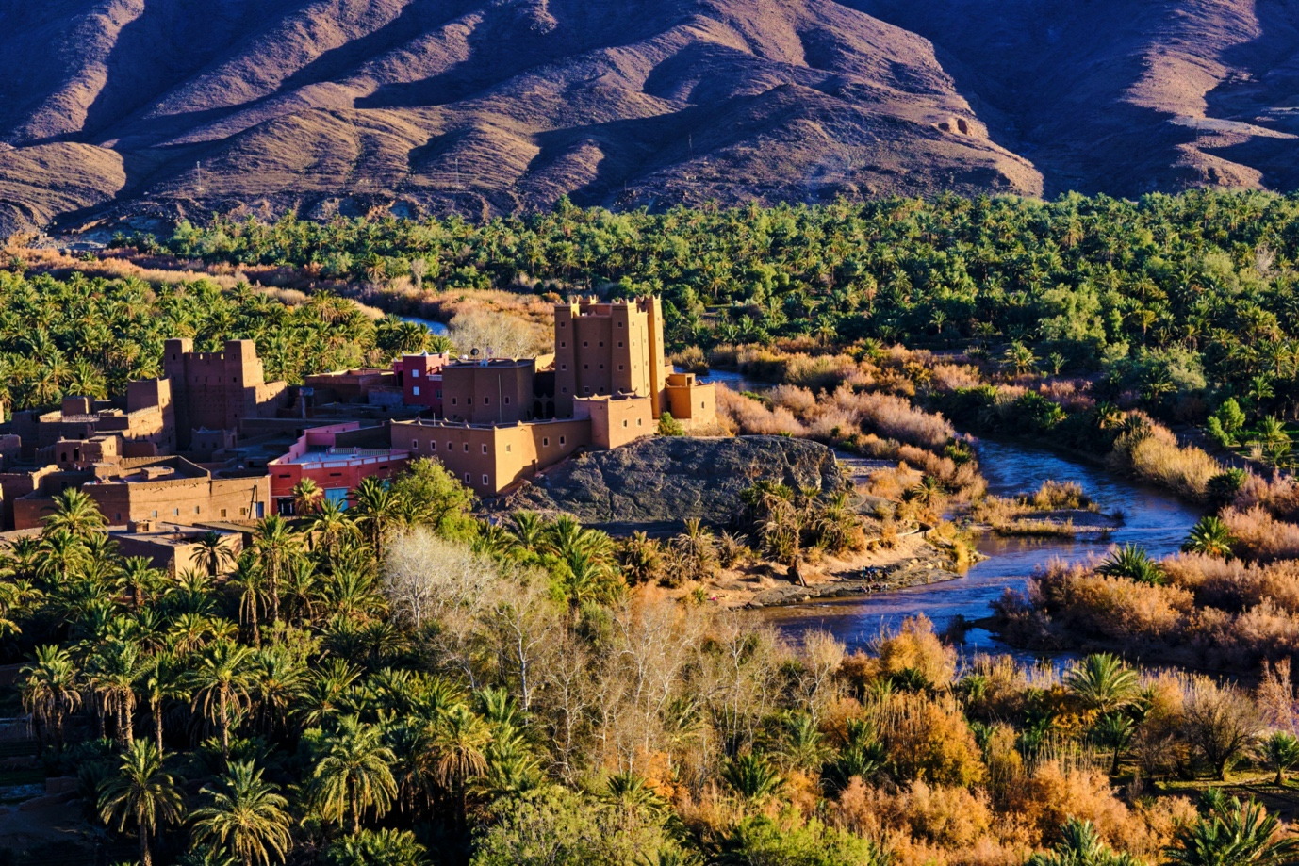

- Figure 3 shows agricultural land use adjacent to the Oued Draa. In the foreground, land is used for growing vegetables. In the background are date palms.
Figure 3 Agriculture in the Draa valley
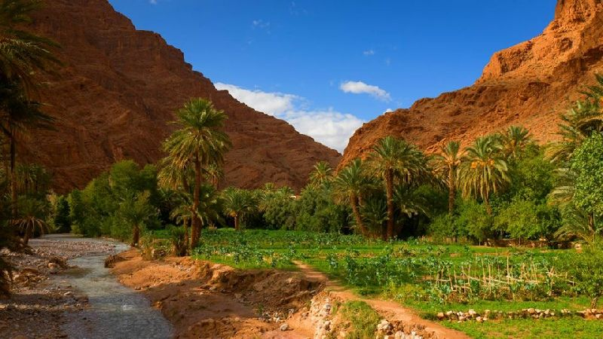
- What is the evidence that the river is experiencing low flow?
---------------------------------------------------------------------------------------------------------------------------------------------------------------------------------------------------------------------------------------------------------------------------
- What name is given to the flat area of farmland to the right of the river?
--------------------------------------------------------------------------------------------------------------------------------------
- Suggest the challenges facing farmers wishing to use the river to irrigate their land.
--------------------------------------------------------------------------------------------------------------------------------------------------------------------------------------------------------------------------------------------------------------------------------------------------------------------------------------------------------------------------------------------------------------------------------------------------------------------------------------------------------------------------------------------------------
- Look at Figure 4. It shows the main characteristics of a date palm.
- Draw a double-headed arrow alongside the palm to show its height of 23m
- Draw a second double-headed arrow to show your approximate height alongside the tree . . . this will give you an idea of how tall they grow!

Figure 4 Diagram of a date palm
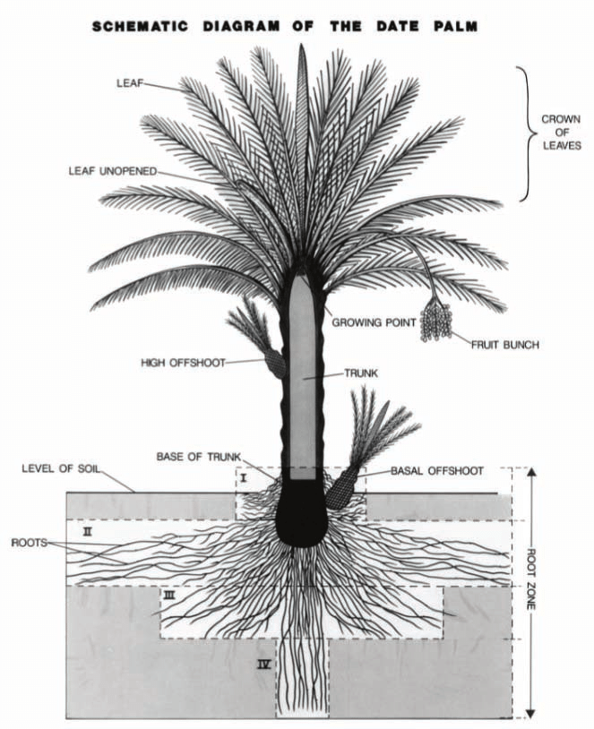
https://www.researchgate.net/figure/Schematic-diagram-of-the-date-palm-Source-USDA-file_fig1_327321891
- Suggest why a large mass of the palm tree’s roots grow laterally (sideways) close to the ground surface.
--------------------------------------------------------------------------------------------------------------------------------------
- Suggest why some roots grow very deep (Zone IV).
--------------------------------------------------------------------------------------------------------------------------------------
- Use the internet to find out more about:
- How the offshoots can be used to grow new palms
- How dates are harvested
- The health benefits of eating dates

- Study Figure 5.
Figure 5 Tourists riding camels in Zagora, Draa valley
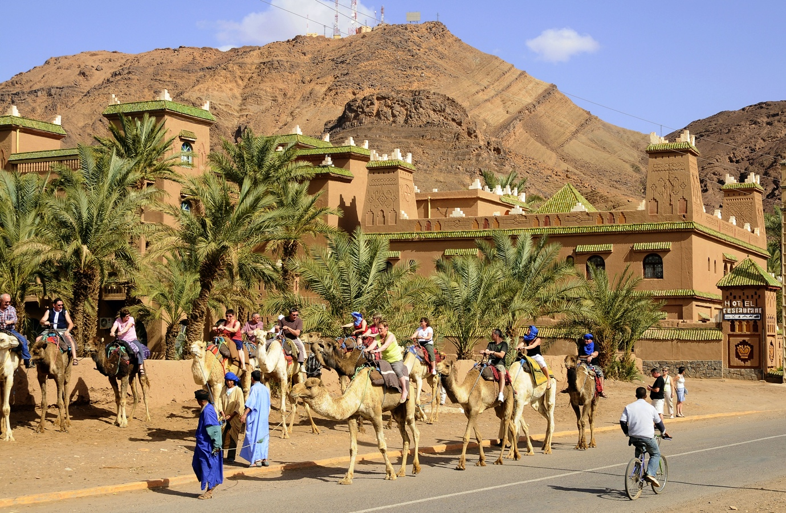
- Use evidence from the photo to suggest why this is a popular tourist destination?
----------------------------------------------------------------------------------------------------------------------------------------------------------------------------------------------------------------------------------------------------------------------------
- Suggest advantages and disadvantages that tourists may bring to the area.
Advantages | Disadvantages

- Ouarzazate is the centre of the Moroccan film industry.
Figure 6 Filming at Ouarzazate
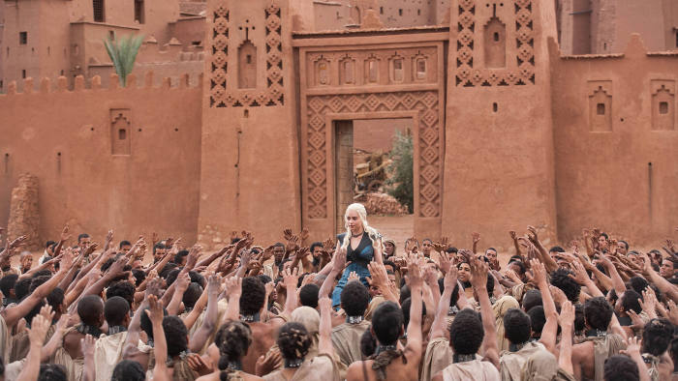
- What TV programme filmed at Ouarzazate is shown in Figure 6?
--------------------------------------------------------------------------------------------------------------------------------------
- Suggest why Atlas Studios decided to locate at Ouarzazate.
----------------------------------------------------------------------------------------------------------------------------------------------------------------------------------------------------------------------------------------------------------------------------
- Water supply is a major issue in the Draa valley.
- What is the main purpose of the El Mansour Eddahbi Dam?
--------------------------------------------------------------------------------------------------------------------------------------
- List two problems associated with the El Mansour Eddahbi Dam.
----------------------------------------------------------------------------------------------------------------------------------------------------------------------------------------------------------------------------------------------------------------------------

- The Noor solar plant near Ouarzazate is the largest in the world.
Figure 7 Noor solar power plant
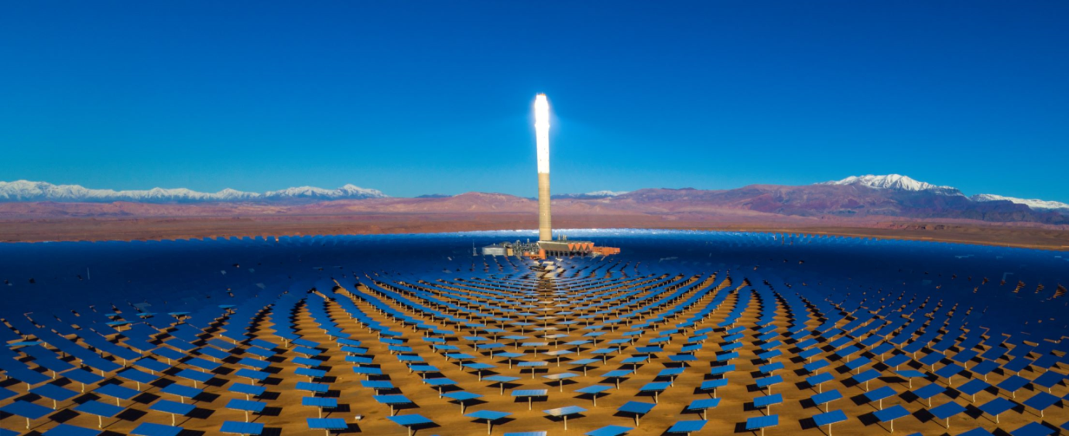
- Using evidence from Figure 7, suggest why this is a good location for a solar power plant.
------------------------------------------------------------------------------------------------------------------------------------------------------------------------------------------------------------------------------------------------------------------------------------------------------------------------------------------------------------------------------------------------------------------
- Salinisation is a high concentration of salt at the surface. It may result from irrigation using water with a high concentration of dissolved salts. Alongside the diagram below, explain the process of salinisation. You could do this in the form of a flow diagram.
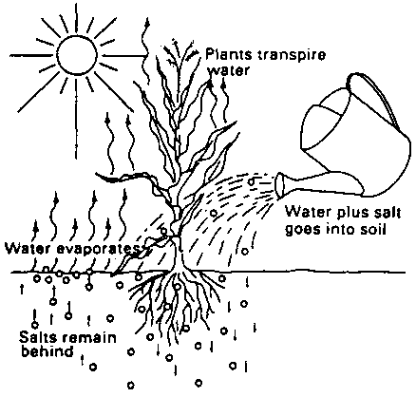
http://www.fao.org/3/r4082e/r4082e08.htm

