Desert landscapes

Use the PowerPoint presentation or the internet to help you with the following activities.

1. Figure 1 shows the desert landscape near Ouarzazate.

**Figure 1 Desert landscape near Ouarzazate**

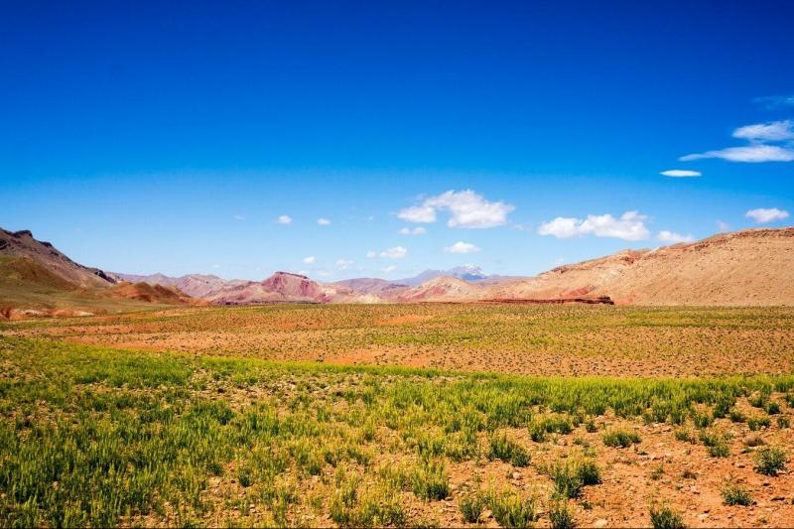

1. Describe the desert landscape in Figure 1.

--------------------------------------------------------------------------------------------------------------------------------------------------------------------------------------------------------------------------------------------------------------------------------------------------------------------------------------------------------------------------------------------------------------------------------------------------------------------------------------------------------------------------------------------------------

1. Suggest reasons for the lack of human habitation.

--------------------------------------------------------------------------------------------------------------------------------------------------------------------------------------------------------------------------------------------------------------------------------------------------------------------------------------------------------------------------------------------------------------------------------------------------------------------------------------------------------------------------------------------------------

1. Figure 2 shows the Tiz-n-Tinififft pass, near Ouarzazate, an example of a desert gorge.

**Figure 2 Desert gorge at Tizi-n-Tinififft**A picture containing outdoor, sky, valley, canyon

Description automatically generated

1. Write detailed labels to describe some of the characteristics of the desert gorge.
2. In the past, Morocco experienced a wetter climate and rivers were much more powerful than they are today. Snowmelt was also more significant. Suggest how present and past processes of weathering and erosion have contributed to the formation of the gorge.

------------------------------------------------------------------------------------------------------------------------------------------------------------------------------------------------------------------------------------------------------------------------------------------------------------------------------------------------------------------------------------------------------------------------------------------------------------------------------------------------------------------------------------------------------------------------------------------------------------------------------------------------------------------------------------------------------------------------------------------------------------------------------------------------------------------------------------

--------------------------------------------------------------------------------------------------------------------------------------

1. Figure 3 shows a mesa close to Ouarzazate.

**Figure 3 Mesa near Ouarzazate**

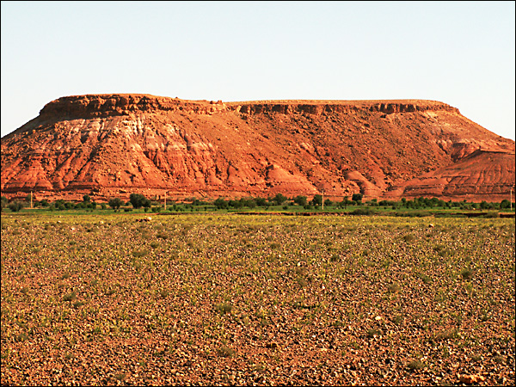

1. Describe the distinctive characteristics of the mesa in the photo.

----------------------------------------------------------------------------------------------------------------------------------------------------------------------------------------------------------------------------------------------------------------------------

1. What is the significance of geology in the formation of a mesa?

----------------------------------------------------------------------------------------------------------------------------------------------------------------------------------------------------------------------------------------------------------------------------

1. What is the evidence that water processes are responsible for its formation?

----------------------------------------------------------------------------------------------------------------------------------------------------------------------------------------------------------------------------------------------------------------------------

1. Study Figure 4 which shows a mountain front near Zagora.

**Figure 4 Mountain front near Zagora**

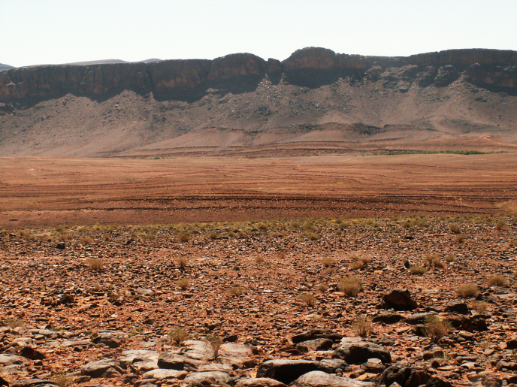

1. Label the following landscape features:

* Alluvial fan
* Alluvial plain
* Pediment
* Reg (desert pavement)

1. Annotate the following diagram to describe the formation of reg (desert pavement).



Time

1. Sand dunes are formed by the wind-blown transportation and deposition of sand. Figure 5 shows sand dunes near Zagora.

**Figure 5 Sand dunes near Zagora**

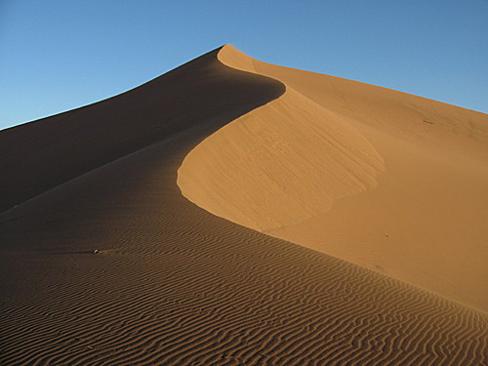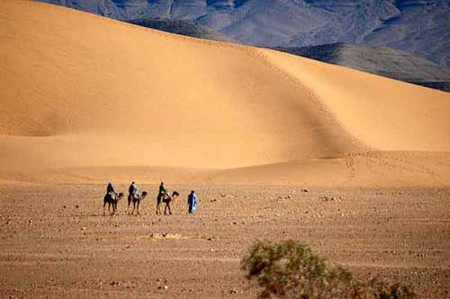

1. Use the following diagram to explain the role of wind transport in the formation of sand dunes. Consider which processes are most important.



----------------------------------------------------------------------------------------------------------------------------------------------------------------------------------------------------------------------------------------------------------------------------

1. Look at Figure 6. Consider the role of wind direction and moisture content in the development of sand dunes.

--------------------------------------------------------------------------------------------------------------------------------------------------------------------------------------------------------------------------------------------------------------------------------------------------------------------------------------------------------------------------------------------------------------------------------------------------------------------------------------------------------------------------------------------------------

**Figure 6 Role of wind direction and moisture content in the development of sand dunes**

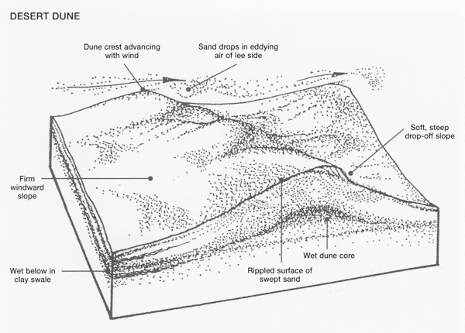

<http://www.anbg.gov.au/photo/vegetation/sand-dunes.html>

1. Figure 7 shows the effects of dune encroachment, a major problem at desert fringes. Use the internet to investigate the issue. Outline the factors affecting dune encroachment and, with reference to examples, evaluate the effectiveness of management solutions.

**Figure 7 Dune encroachment of farmland near Tinfou**

