Case Study:
Issues and Management in
The Draa Valley
________________________________

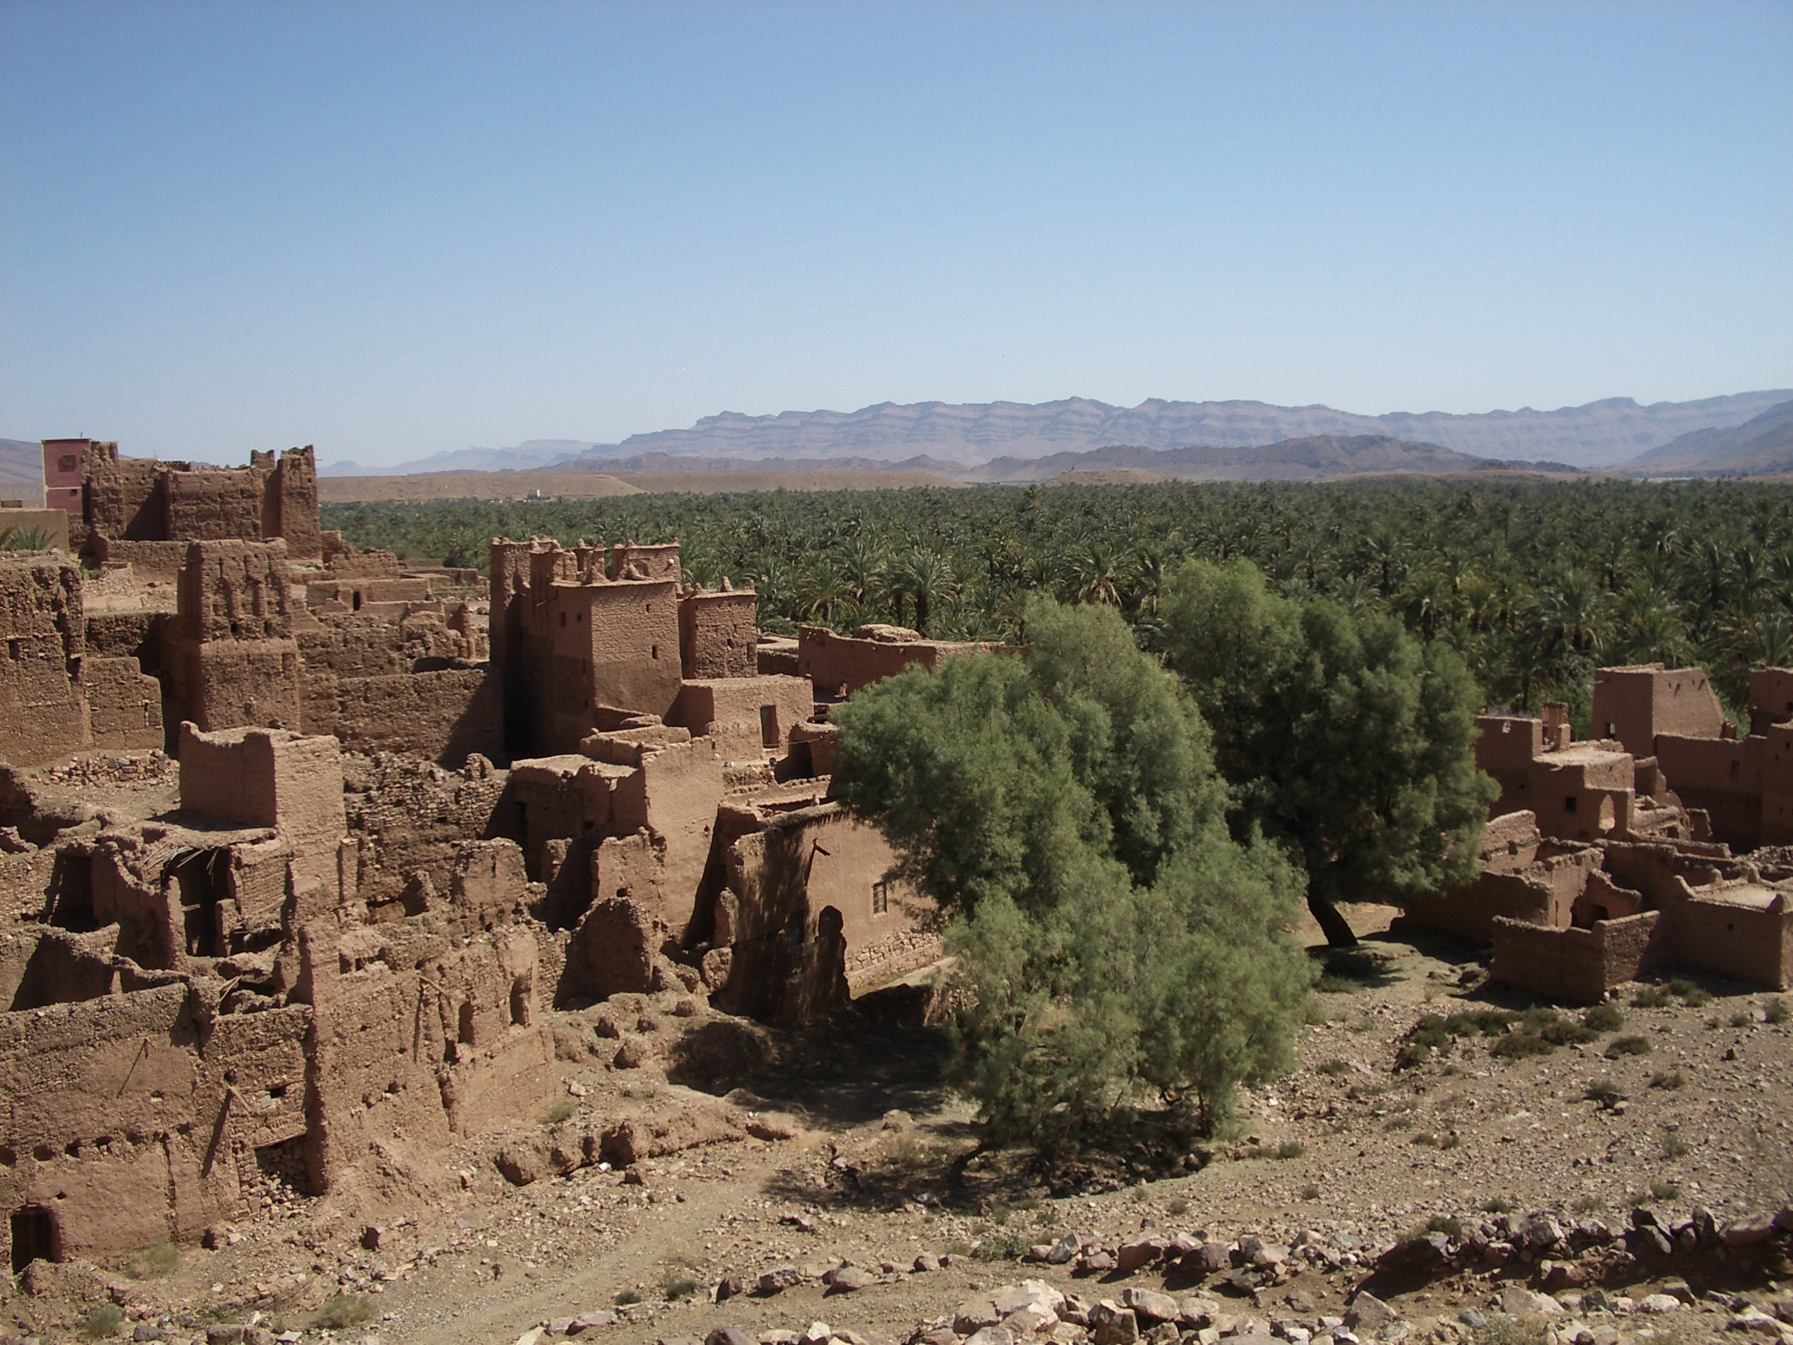

www.discover.ltd.uk
info@discover.ltd.uk
© Discover Ltd 2021

Case Study: Issues and Management in the Draa Valley
Teachers Notes
This case study looks at the Draa valley and the desert of Southern Morocco and examines some of the issues associated with the development of this area. Key areas examined are:
- Challenges within the Draa Valley
- The growth of Tourism
- The development of Ouarzazate as a key town
- Flood hazards within the desert
Although there are no specific fieldwork tasks, the issues described within this case study could be examined in more detail on the ground.

Specification Links
International Baccalaureate (Diploma Programme)
3.3 Arid Environments and their Management
AQA GCE Geography
Unit 1 Physical and Human Geography
Optional Physical Topic Desert environments
OCR GCE Geography
AS Unit F761: Managing Physical Environments
Hot arid and semi-desert environments
WJEC GCE Geography
Unit G3 Contemporary Themes and Research
Theme 1 – Extreme Environments – Desert

References
Michael Raw (2008) “OCR AS Geography” Philip Allan
Bouaouinate, Beckendorf,Popp “Mass Tourism and a Flood Hazard in the Desert”
Schlutter “Ouarzazate – “From a remote French Military Post to a Provincial Capital”
Graefe “Water Conflicts and the New Role of the State in Rural Morocco”
Popp “Road of the Kasbahs” – a Tourist Product in Southern Morocco”
Above from Journal - Geographische Rundschau Vol 4 No 3/2008

Background
The Draa river valley is one of Morocco’s largest rivers. Its catchment covers nearly 35000 Km2, and it varies in altitude from 4071m to 450m. The Draa rises in the High Atlas Mountains and then flows away from the sea for some 200km into the arid lowlands of southeast Morocco and the Sahara Desert. As it moves away from the mountains, aridity increases due to:
- The rain shadow effect of the High Atlas Mountains
- The permanent sub-tropical high pressure over the Sahara
- Mean annual rainfall downstream from Ouarzazate is barely 100mm, falling to around 60mm in Zagora, whilst in summer temperatures rise to over 40oC. Annual evaporation for Ouarzazate is 3300mm per year.

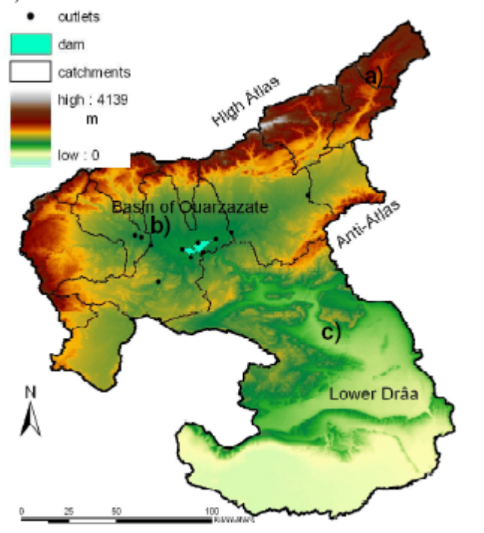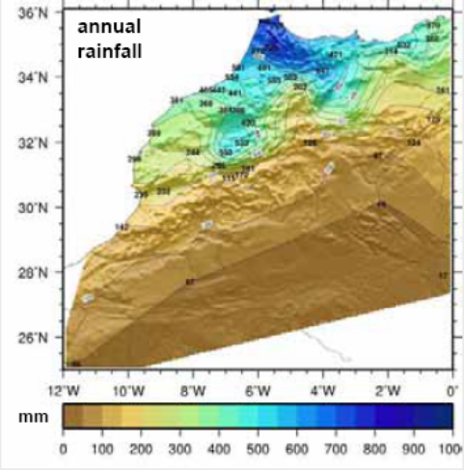

Agriculture
The Draa is therefore seen as the lifeblood of southeast Morocco, a strip of green in the otherwise parched environment. In total 43000 ha are irrigated within its catchment. Around 80% of this water comes from the Draa and its tributaries whilst the rest is from groundwater. Because of the river around 225,000 people live in the Draa valley. Most are subsistence farmers surviving on small holdings of just one or two hectares. Traditionally a poly-culture approach has been taken to farming with a mixture of dates, barley, fruit and vegetables being grown. This has allowed the local population to prosper despite the harsh arid environment in which they live. Where the irrigation stops, the desert begins.

Tourism
In recent years, tourism has provided a valuable income to the people of the area. Around 8% of the active population is now involved in tourism, in both the formal and informal sectors. The larger settlements of Ouarzazate and Zagora have both grown into important tourist centres within the valley. The airport in Ouarzazate has been expanded (new terminal in 2001) and a new airport opened in Zagora in 2007. The encouragement of “tourisme rural” by the Moroccan government and its shift away from towns such as Agadir has benefited the Draa. Alternative tourism such as desert trekking and “off the beaten track” is increasingly being promoted within the tourist industry. The Draa has also made use of its historic and cultural features such as the Kasbahs of the region.

Film Industry
Since 1984 Ouarzazate has been an important location for film studios. Although Morocco had been used for filming before (Lawrence of Arabia) the climate (good light and guaranteed sunshine), economic conditions (low labour costs!) and geographical location have encouraged directors to produce films in the area. The film studies have now developed into tourist attractions in their own right and Ouarzazate is now commonly referred to as “Mollywood”.

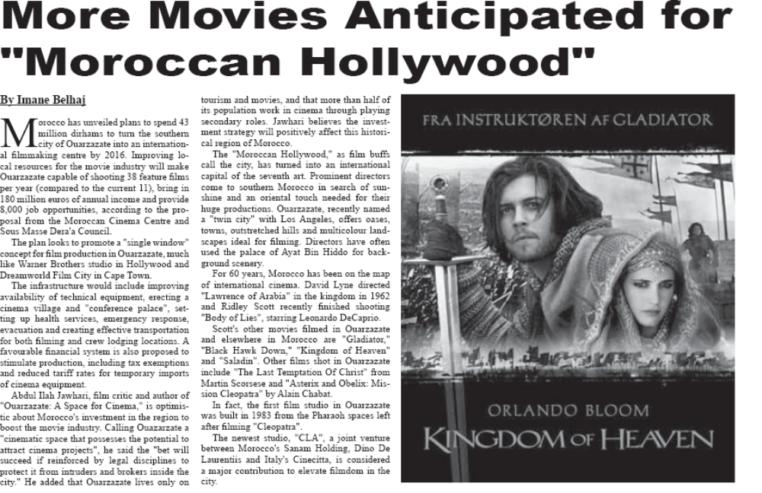

Challenges within the Draa Valley
The increased popularity of the Draa Valley has presented it with a series of challenges, environmental, economic and demographic challenges.
Environmental Challenges
Probably the greatest threat to the Draa valley is the issue of water. Issues of water in Morocco are not uncommon and have lead to conflict among users in the past. Within the Draa however a number of factors have increased pressure on this scarce resource: Over the past 15 years precipitation in the High Atlas has declined. Snowfall has become increasingly variable and snow packs in the High Atlas have steadily declined.
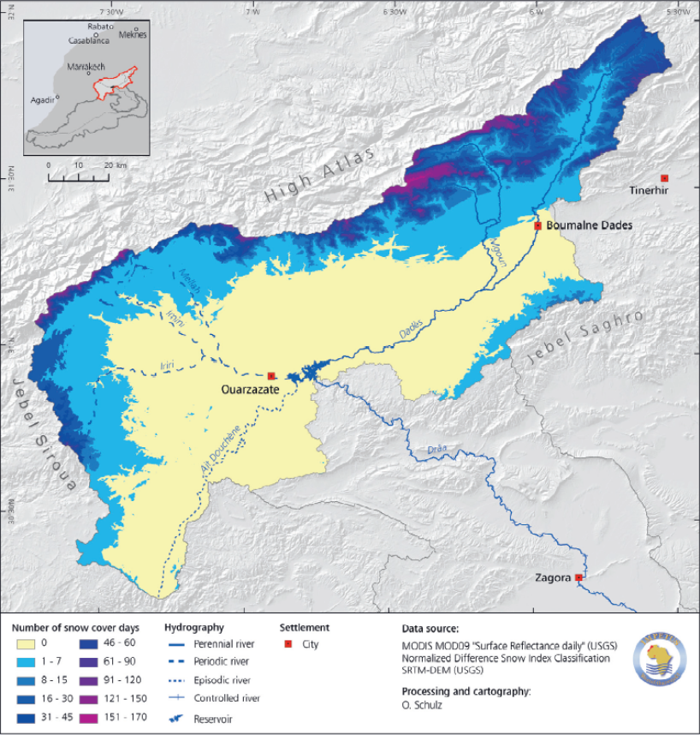
Mean snowfall duration in the High Atlas 2001 – 2006

Water demand from irrigation and tourism has been increasing by 3% per year. Population growth in the Draa valley is high, around 2.5% per year.
Salinisation of farmland is increasing, especially in the southern valley. Over irrigation of farmland has caused localized rises in water tables. Salts dissolved within the water are drawn to the surface by high temperatures, where evapo-transpiration deposits them as a
saline crust.

In other parts of the Draa valley the increased mechanization of pumps has caused the over exploitation of the ground water. In places the water table has fallen between 3m and 6m.

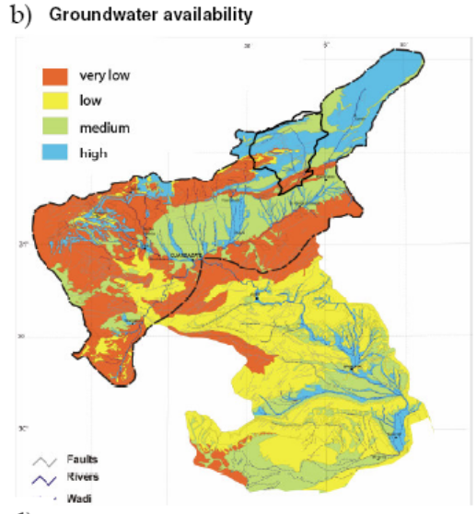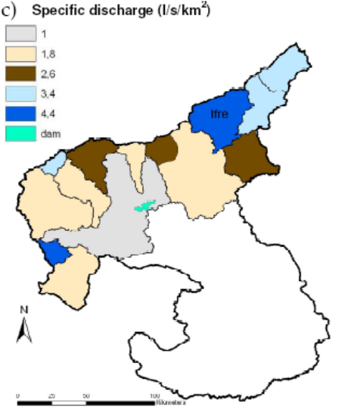
Since 1972 most of the river flow in the Draa valley has been regulated by the Mansour Eddahbi dam near Ouarzazate. However, the reduced precipitation has resulted in reduced inflows and consequently reduced outflows from the dam. This problem has been increased by increased soil erosion and thus increased sedimentation within the Draa river. Within the catchment soil erosion is estimated at 35tonnes per ha per year and the capacity of the reservoir that was 560 million m3 on construction is now only 440 million m3.
Increased encroachment by desert sands, around 50 ha of agricultural land is being lost per year.

Demographic Challenges
Population growth in the Draa valley is at a high rate, around 2.5% per year (compare with 0.2% in the UK). Three factors account for this:
A young age structure. More than 60% of the population is less than 30 years old.
A high fertility rate among the rural population
A relatively low and falling mortality rate.
This population growth is bringing increased pressure on the limited natural resources, resulting in over-exploitation of water resources, farmland and the destruction of ecosystems.
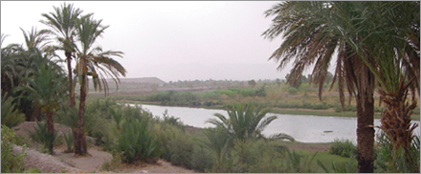
Economic Challenges
The Draa valley is one of Morocco’s poorest regions with average incomes of barely $300 a year , well below the country average of $1200. Around two in every five people are considered to be living in poverty. Literacy is very low, especially among rural women (over 60% illiterate). There are now growing differences between the majority rural population and the urban dwellers in the more prosperous towns such as Ouarzazate and Zagora. Extras in the film industry can earn between $20 and $50 dollars per day so at times something like 60% of the population of Ouarzazate has been estimated to be involved on big film sets. Rural incomes have been further reduced by the disease “Bayoud”, first identified in the Zagora area in 1870, which has damaged the palm trees and date crop. Within Morocco loss of crop due to fruit rot caused by the disease has been estimated to be as high as 40%.

The Growth of Tourism within the Draa Valley
Since its independence in 1956, Morocco has been encouraging the growth of international tourism. Initially much of this followed the traditional “Mediterranean model” with the sun, sea and sand approach. Settlements such as Agadir were developed to cater for this market. Whilst Agadir still attracts 40% of all international tourists, as tourist tastes have changed and competition for the traditional markets has increased, Morocco has looked for new types of tourism. In this context the favourable climate, a mix of attractive landscapes (coasts, mountains, deserts and semi-deserts) and cultural landmarks have all been used to attract a new type of tourist. This in turn has opened up new peripheral sites outside of the traditional tourist areas of Morocco. Not all sites bring in the tourists and a number of features can be identified that will determine the success of a region.

The Draa valley has been able to offer tourists the benefits of:
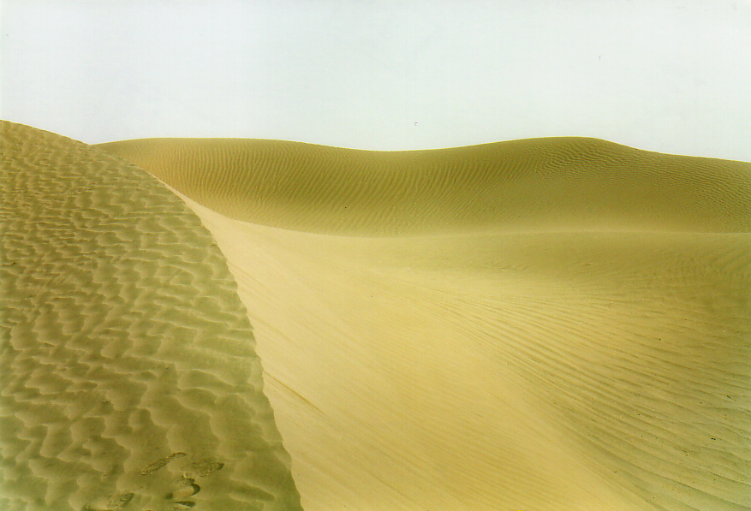
The natural factors.
In mountain trekking both the height and number of peaks available is important. In the case of desert areas, sand deserts have proved to be far more popular than rocky deserts. Increasingly the dunes areas to the south of Zagora are proving to be the ideal scenery for an experience of the desert. The Erg Chebbi area has dunes up to 150m in height. Dunes at M’Hamid

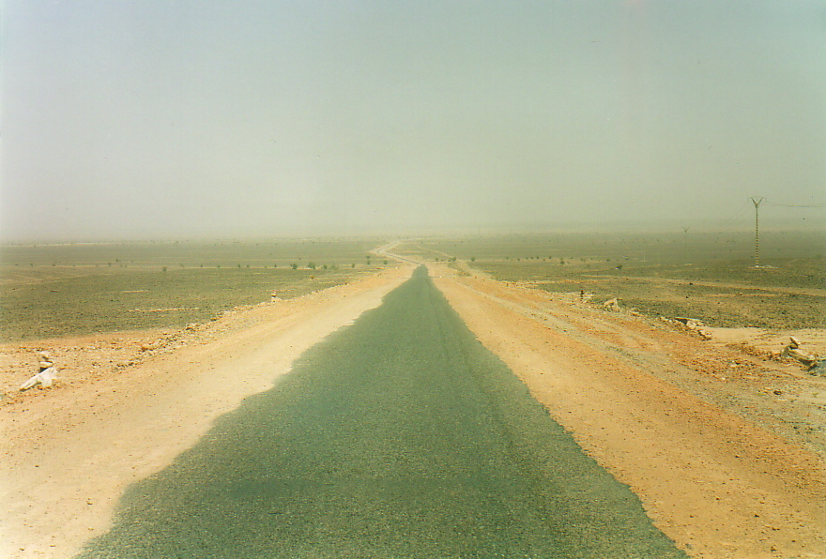
Accessibility and low transport costs. Although there are always some people wanting to get away from the crowds, for many there is also a need to be able to travel easily and quickly. The trend towards shorter breaks encourages those areas that are accessible. The development of airports in Ouarzazate and Zagora, plus the extension of the paved road to Taouz in 2005 has opened up most of the Draa valley and the desert beyond. What was originally only accessible to 4x4 vehicles is now open to tourist buses and cars.

Tourist Infrastructure. A place must be able to cater for the diverse needs of tourists. New hotels, restaurants, guest houses and other tourist facilities have all developed over the past 10 years.
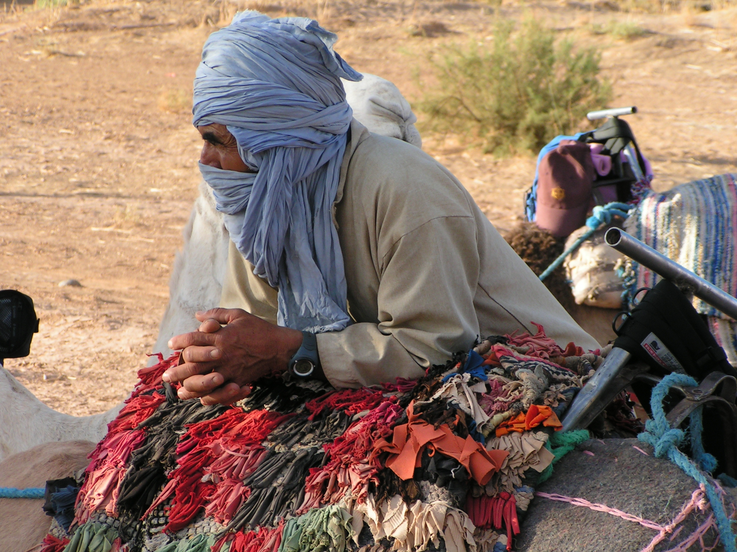
Ethnotourism. The use of ethnic diversity, meeting the Berbers or the Blue men of the desert.

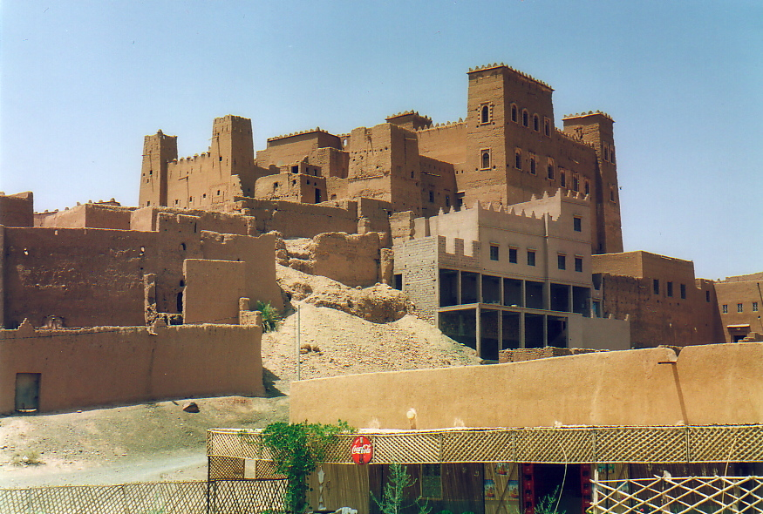
Cultural Tourism. “The Road of the Kasbahs” has been marketed very successfully as a destination for cultural tourists, together with the designation of “Ksar Ait-Ben-Haddou” as a World Heritage site (1987). However, many of the Kasbahs are now being converted into hotels, restaurants and museums and few original buildings remain. Unfortunately, little of the income from tourism has been reinvested in the preservation of these buildings and it may be that argued that much of the true architectural heritage of the area has been lost. For most tourists however, this does not seem to be a major issue.
Ksar Ait Ben Haddou

The Development of Ouarzazate as a Key Town
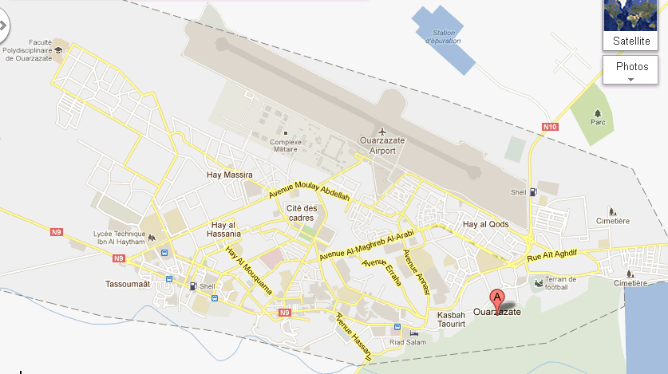
Ouarzazate (Berber for “without noise”) is now known as “The door to the desert” and is an important regional centre within Morocco, a provincial capital, home to the Moroccan film industry and an important tourist destination. However, in 1900 it consisted of an oasis, a handful of Kasbahs, surrounded by grazing and agricultural land. In 1928 the French established a military camp providing the foundations for the development of the future settlement. In 1938 a small dam was constructed to in the Oued Imini near Tifltoute to supply water for irrigation and the growing settlement. The first urban development plan was designed in 1954, but before it could be implemented Morocco gained its independence in 1956. Independence brought administrative restructuring and Ouarzazate became the provincial capital requiring the construction of new administration buildings and residential quarters. The areas of Hay al Mouukawama (1961), Hay el-Bahja (1964), Cite C.B.M. (1965) and Tametkalte (1967) were developed together with other public buildings such as the hospital and school. These were necessary to encourage highly qualified civil servants to move to rural Ouarzazate, but also attracted migrants from the rural hinterland. Further residential areas were constructed as the population continued to rise.
Date | Population of Ouarzazate
1936 | 800
1960 | 4095
1971 | 11034
1982 | 17171
1994 | 39203
2002 | 57175

Impact of the Mansour ed-Dahbi Reservoir
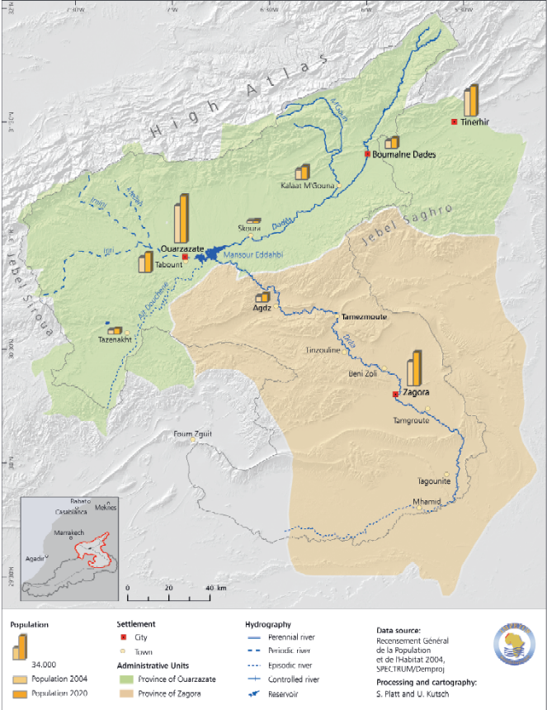
The construction of this important dam on the eastern side of Ouarzazate resulted in the flooding of around 1000 hectares of irrigated land. Around 8000 inhabitants of the area also had to be relocated. Government relocation projects such as Idelsane 20km north of Ouarzazate failed due to inadequate housing, poor infrastructure and salination of the soil, resulting in many of the people moving into the town. This resulted in an informal real estate market and led to a number of unstructured developments of low-income housing in the less desirable areas of the town, particularly around the old Ksar area.
Estimated Population growth for settlements in the Draa Valley 2002 to 2020

Regional policy and Tourist Development
Since the 1980’s Morocco has used tourism as a catalyst for regional development in peripheral areas of the country. With Ouarzazate at an important crossroad of the major routes, and with access to the natural and culturally attractive Draa valley the intention was to promote long-term recreational tourism. Developments included:
- An area to the east of the main settlement was designated for hotels and is still the site of most of the higher-class hotels.
- Private investment was attracted through tax benefits and low interest loans.
- Infrastructural improvements continued including the creation of a promenade (with cafes, restaurants, banks, supermarkets and bazaars).
- Conversion of the military airstrip into an international airport
- Removal of the weekly market from the centre to the outskirts.
- The administrative centres were reorganized providing an open airspace for ceremonies
- New bus terminal constructed, and taxi rank created.
- Industrial area created on the western outskirts
- Creation of another tourist area to the south of the river, largely catering for budget tourists, together with cafes, restaurants and bazaars.
Water Resources
The change of Ouarzazate from an oasis into a mid-size Moroccan town has not been without its problems. A once rural society has changed to an urban way of life. This has led to major problems in terms of the supply and access to water. Water consumption has massively increased as has the problem of wastewater management. With this comes the degradation of ground water supplies and conflicts between different water users. With both tourism (where water is supplied at a subsidized rate) and domestic consumption increasing, the amount available for irrigation use downstream is reduced. Since the 1980’s the priority for the dam has changed from hydro-electric production to water supply, as so little water is now available to produce electricity. With further pressure on ground water supplies, reduced precipitation in the High Atlas, an increasingly urban population in the Draa valley (urban growth is at 3.8% compared to 0.8% in rural areas) and problems of silting within the reservoir (as much as 50% capacity lost within 30 years) this conflict can only get worse. For the moment the urban elite will continue to receive this valuable resource, whilst the local farmer and economically weak households are left behind.

Flood Hazards within the desert
Before the construction of the Mansour ed-Dahbi dam and reservoir, flooding was not uncommon along parts of the Draa valley, with major floods in 1948/49, 1956 and 1966. Since the construction of the dam these events have become far less frequent, but flood events do still occur mainly due to snowmelt and/or catchment wide precipitation generally in spring or autumn. Between March 31st and April 1st, 2002, a heavy rainstorm crossed Morocco, bringing with it exceptional precipitation totals:
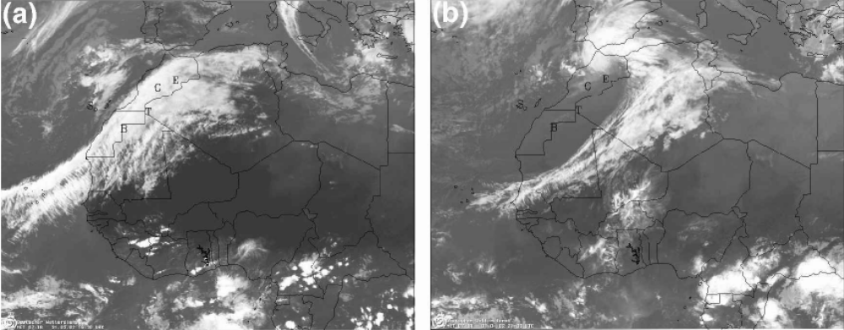
Meteosat images (a) 16.30 on March 31st (b) 21.00 on April 1st 2002

Ouarzazate received 72mm within 24 hours or about 62% of its annual rainfall and about seven times more than the average for March. This resulted in flash floods, flooding of roads and collapsing walls and buildings.
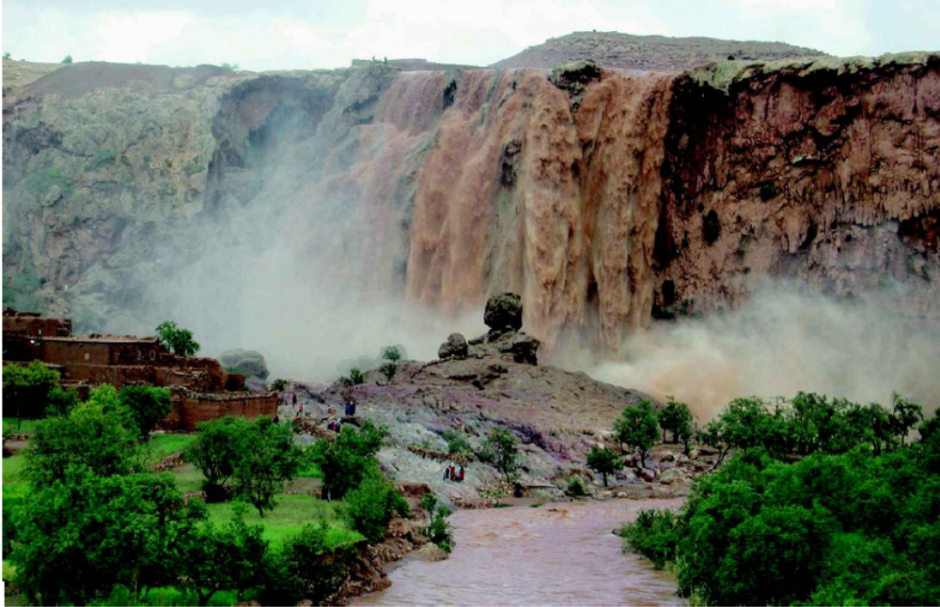
Normally intermittent waterfall Chute d’Ifri on April 1st 2002

Erg Chebbi Floods May 2006 – a “Berber tsunami”
Another event took place further into the desert on the night of 26th/27th May 2007 in the Erg Chebbi area. The area, famous for its sand dunes up to 150m in height and with the surfacing of a road (2002) was now a popular area for tourists. The area which had suffered drought for more than two decades received more than its 50mm average precipitation in just one night. Also, a series of normally dry valleys coming from the High Atlas were turned into raging rivers. The event is described by a tourist below:

“As the obscure sunset made its way partially below the horizon, the rain began, falling harder and harder. A once flowing tributary filled again with water that began its ravage assault on area of auberges and hotels. Those in tents in the desert would have to survive the flooding, which now turned to hail. Within ten minutes a new river flowed. Within twenty minutes, cars were covered in sand and structures that had stood for thirty years lay in piles of sandy slush. One Frenchman driving his 4x4 got stuck and had to leave his car the rest of the night. It was almost completely covered by sand and no way could it be moved the next day. Another Australian tourist claimed, "We were out of the way of the flowing river. We were actually standing on the roof of the hotel. It all seemed so surreal, so out of place. As we watched the lightning strike manically across the sky, we watched as bats circled above catching as many insects as they could."

As the sun rose early the next morning, over 250 small buildings, houses, and animal sheds that once stood were no longer in sight. No one was sure if there were any casualties. Later in the morning, it was reported that six or seven people were killed, among them a few tourists. Many elders in the southern regions near Merzouga remembered a storm when they were younger, "...in grade school, right at sunset, just like this," one claimed. Time tends to take its own rhythm in the Maghreb region of Africa. Sometimes it even stands still. When people talk about events that happen in their lives, they tend to relate it to other events that occurred, rather than dates. The massive flooding, cold rain, and the earth-vibrating thunder of this night will be etched deeply in the flowing sands of time for those who call the Sahara Desert their home. Hopefully, a tragedy such as this will not happen again. Hopefully, when these kids are older, they will only have to tell stories of this eerie night when even Erg Chebbi seemed to hide. Hopefully, those who have lost all to the storm will regain their livelihoods and carry on”.

It was fortunate that more people were not killed as the town of Merzouga had been growing on the back of a thriving tourist industry, 1,400 to 5,000 from 1997 to 2006). A number of features contributed to the damage caused by this flood:
- The tourist boom had brought considerable investment in guesthouses and hotels, growing from just 16 in 2003 to 71 in 2006.
- Many buildings had been constructed in the most attractive sites, along the depression of the dry river bed and at the foot of the dunes, all with considerable flood risk.
- Sandstorms had blown fine material into the bed causing the water to flow at a higher level.
- The land surface was almost entirely dried out so water could not permeate into it.
- Damage was exacerbated by the use of traditional mud and clay construction, unable to cope with the extreme rainfall and flood waters.
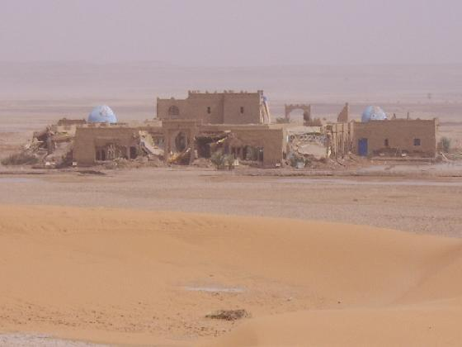
Riad destroyed in the floods at Merzouga.

A small local dam constructed to trap precious rainwater collapsed destroying nearby buildings.
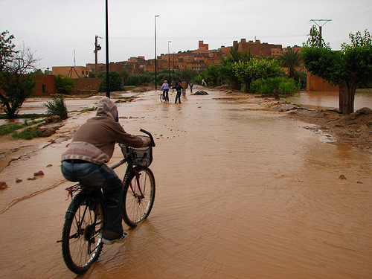
Reaction among people the locals and foreign guesthouse owners to the flood differed markedly. Some locals felt that the flood was punishment from god because they had tolerated aspects of tourist behaviour not in accordance with Islam, such as consumption of alcohol and immodest clothing. Other locals blamed the government for not constructing a dam that would have held back the water and prevented the catastrophe. Foreign investors blamed the local authorities for allowing construction on areas of risk including the actual riverbed.

Since the floods the area has recovered with astonishing rapidity. In June 2006, the region was classified “at risk from flooding” and included within the “Plan national de prevention contre les inondations” (National Plan for flood prevention). This provided the legal basis for a ban on construction at the edge of riverbeds and within wadis. Tourist accommodation owners have rebuilt away from the river but are reluctant to give up the attractive sand dune locations. Although tourist numbers dipped slightly after the flood, numbers are again rising.

From an ecological point of view “the Berber tsunami” has had some positive benefits. Temperatures for the summer of 2006 in the area were far more pleasant due to the numerous small lakes and ponds left by the floods. Tourists benefited from a glorious landscape with bodies of water contrasting with the splendour of the dunes. Water tables rose and many dry wells were able to be used again.

