landforms of hot desert environments

www.discover.ltd.uk
info@discover.ltd.uk
© Discover Ltd 2021

Landforms of Hot Desert Environments

Aims
- To investigate the distinctive physical landscapes and processes of hot desert environments
- To investigate specific landforms of hot desert environments, and the processes responsible for their formation

Questions for Investigation
- What are the main processes of weathering operating in desert environments? To what extent are physical and chemical processes important?
- What is the evidence for the work of running water in fashioning desert landscapes? Landforms include gorges, mesas, alluvial fans and wadis.
- What is the evidence for the work of wind in eroding, transporting and depositing sediment in desert areas? This might include deflation in pebble-covered reg deserts, the formation of ventifacts, and the deposition of sand dunes.
Fieldwork will be carried out at various places, including to the west of Ouarzazate and the area around Ait Ben Haddou, the Tiz-n-Tinififft pass, the Draa valley and around Zagora.

Syllabus Links
International Baccalaureate
Explain wind and water-formed features, flash floods
OCR
What processes and factors give hot arid/semi arid environments their distinctive characteristics?
- The impact of climate and weathering on the landscape
- The way that wind and water shape the landscape to produce distinctive landforms, including sand dunes, canyons and canyon landscapes, sculptured rocks, wadis and salt pans
AQA
Arid geomorphological processes: mechanical weathering; the effect of wind; the effect of water
Landforms resulting from wind action: yardangs, zeugen and sand dunes
Landforms resulting from water action: pediments, inselbergs, mesas and buttes, salt lakes, alluvial fans, wadis and badlands

Introduction
The south-east of Morocco, beyond the High Atlas Mountains, forms part of the fringe of the Sahara Desert. The landscape becomes increasingly arid, vegetation is sparse, and settlement is often confined to oases alongside rivers.
In this region of Morocco there is the opportunity to investigate several different desert landscapes, especially between Ouarzazate and Zagora.
The deserts of the world are characterised by distinctive landscapes, mainly due to their aridity and high temperatures, lack of vegetation and poorly developed soils. The Sahara has low and very irregular rainfall and is one of the hottest places in the world. Day-time temperatures may reach over 50ºC; nights are cooler, and frost may be experienced during the winter. The plants which can grow in such a region are known as xerophytes; there is little variety of species and they are widely scattered. The processes of weathering, erosion, transportation and deposition are also distinctive, producing a variety of different landforms.
Some desert regions are dominated by the action of wind, some by water, and some by a combination of both. The effects of climate change on desert landforms must also be considered: there is evidence that the desert areas once experienced much higher rainfall than at present and many of the landforms may be relict features.
Desert landscapes are very diverse. The familiar vast sand dunes are typical of only a part of the world’s deserts. Several different types of desert landscape have been distinguished:
- Desert uplands, where the geology has a significant impact on relief, bedrock is exposed, and relief is high.
- Desert piedmonts, which are zones of transition separated from the uplands by a sharp break of gradient. They receive runoff and sediments from the uplands and have both depositional (e.g., alluvial fans) and erosional forms (e.g., pediments and stone-covered plains called reg).
(The above landscapes can be seen to the south east of Ouarzazate and the Draa valley)
- Desert Rivers and floodplains. Most rivers in desert regions are ephemeral, only carrying water following occasional periods of rainfall. Though often short-lived these can generate high levels of discharge, partly due to the intense nature of the rainfall and lack of vegetation cover.
Some rivers are permanent, usually having their source outside the desert region. Exogenous rivers have their source in the mountains, beyond the desert margins. An example is the river Draa which has its source in the High Atlas Mountains, flows south-west towards Zagora before petering out in Algeria, without reaching the sea. Another example is the river Dades, which also has its source in the High Atlas and flows westwards towards Ouarzazate where it becomes a tributary of the Draa. Both have a permanent flow, supplemented in Spring by snowmelt from the mountains, and are lined with oases of cultivation and settlements.
- Sand deserts, known as erg, are characterised by sand dunes, and tend to be beyond the limits of active fluvial activity. They often derive their materials by wind action removing debris from pediments and flood plains.
(Small areas of sand dunes can be seen around and to the west of Zagora)

Weathering in Arid Environments
Due to the lack of moisture, vegetation and poor soil development mechanical weathering dominates in arid environments, as evidenced by the abundance of angular weathering products, although processes of chemical weathering should not be discounted.
There are two main types of mechanical weathering: that produced by insolation and that produced by salt.
Insolation weathering is the rupturing of rocks and minerals as a result of large daily temperature changes which lead to temperature gradients within the rock mass. During the heat of the day the temperature of rock surfaces may exceed 80 degrees, but rapid cooling at night leads to high tensile stresses in the rock, resulting in rock fracturing. Insolation weathering leads to:
- granular and block disintegration, and
- exfoliation
Exfoliation occurs when the surface layers of rock peel away, and newly exposed surfaces may experience pressure release.
Granular disintegration occurs due to the differential expansion and contraction of minerals within the rock, causing it to break down into small particles.
Block disintegration often occurs in well-jointed rocks, such as sandstones, when large blocks may break off from the rock surface.
Salt weathering is also important in desert areas. Low rainfall levels mean that salts of various types accumulate on desert surfaces. When a solution containing salts is either cooled or evaporated salt crystals will form and the pressures accompanying salt crystallisation can mechanically break up the rocks. Also, salt crystals expand when water is added to their crystal structure (hydration) from rainfall, dew or fog, resulting in rock fracture – this is a combination of both mechanical and chemical weathering.
Desert varnish is an example of chemical weathering in deserts. Desert varnish is a smooth black or dark brown coating, composed of manganese and iron oxides that accumulates slowly on rock formations and stones in desert environments. Fine, windblown clay particles are a critical ingredient in forming the varnish which first forms on rough, porous surfaces. These surfaces allow dew and other moisture to collect, depositing a thin film of clay when the water evaporates. This film of sediment on the rock's surface encourages water to migrate through tiny pores inside the film, depositing traces of manganese and iron as the water evaporates. On the underside, where it is not exposed to the air, a varnished rock often acquires a glossy red-orange finish through interaction with water and minerals in the soil.

The work of rivers
Present and past river action is often very important in moulding desert landscapes. Although rainfall quantities may be low overall, substantial falls may occur from time to time. Many desert surfaces have a number of characteristics that enable them to generate considerable runoff from quite low rainfall intensities. There is a lack of vegetation cover to intercept rainfall and infiltration rates are often low.

Desert gorges or canyons
Mountain regions in deserts are often incised by narrow, steep-sided valleys, or gorges, that may or may not have a river at the bottom. Good examples include the Dades and Todra Gorges in the Dades valley north-west of Ouarzazate, and the gorges cut into the Tiz-n-Tinififft pass across the Anti-Atlas Mountains south-west of Ouarzazate. They are formed by rapid vertical erosion by vigorous fast flowing rivers.

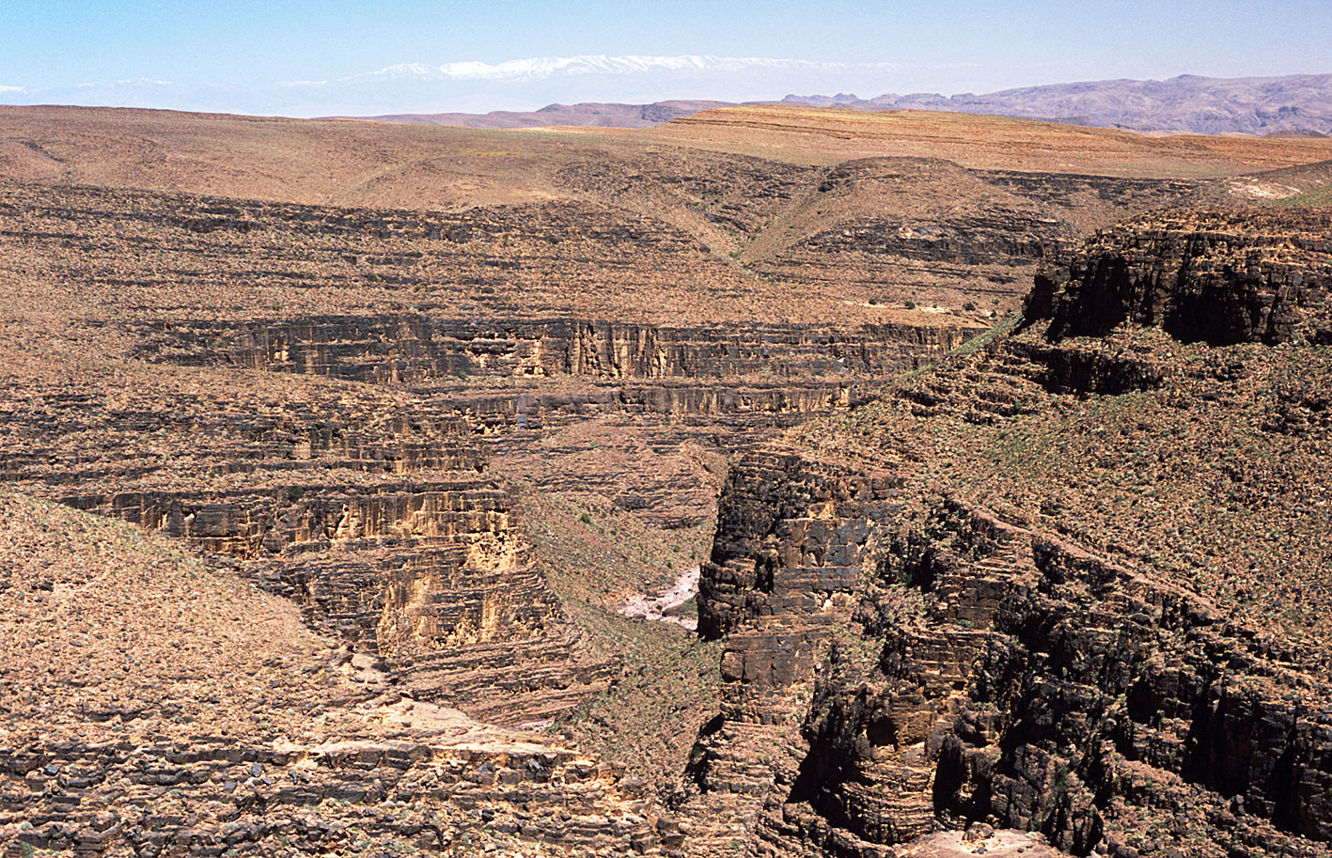
Tiz-n-Tinififft pass
The picture above shows a deep, steep-sided gorge cut into gently dipping sedimentary rocks of the mountain plateau at the Tiz-n-Tinififft pass. The gorge is normally dry but can carry substantial runoff following heavy rainfall and shows evidence of rapid vertical fluvial erosion.

Alluvial Fans
A characteristic feature of desert drainage systems are alluvial fans. These are cones of sediment that occur at the mouth of a canyon between the mountain front and a low lying plain. They form where rivers emerge from canyons in their confined upper mountain courses. At such a point the river can spread out, dissipating energy and decreasing its velocity, so that deposition of sediment occurs. They form most easily where there is a sharp juxtaposition of mountain and lowland. The types of flow that deposit material on the fans range from simple streamflows to highly viscous mud and debris flows. The channels are unstable, shifting laterally over a wide area and alternately cutting and filling themselves.

Wadis
Desert stream channels or valleys are called wadis, which are normally dry but can be subjected to large flows of water and sediment following periods of rainfall. Because of the character of desert rainfall, such flows are sporadic in time and space. It is also common for any one stream to carry discharge along only a portion of its course and floods often peter out because of losses from seepage and evaporation. When these streams flow, they carry a considerable sediment load.

Ouarzazate
West of Ouarzazate the landscape is dominated by wide alluvial plains and plateaux above which rise isolated flat-topped hills, or Mesas.
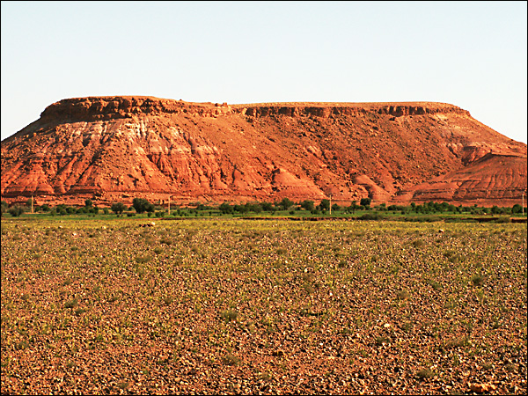
Mesa west of Ouarzazate
A mesa is an isolated hill or mountain that has a flat, table like top and steep sides, edged by cliffs or bluffs. These are characteristic landforms of arid environments. Mesas were originally parts of plateaus that were worn away by erosion over long periods of time. Buttes are smaller than mesas and have a more uniform shape. Mesas and buttes form in areas of horizontally bedded rocks, and the flat top is formed by a more resistant cap rock. Weathering of the cliff edge of the plateau takes place due to the physical process of block disintegration, and the resultant angular rock fragments litter the debris slope. Water erosion is also evident on the debris slope, forming a series of parallel gullies. The debris is thus transported to the extensive plain below
These sedimentary deposits were probably laid down during the Pleistocene under periods of higher rainfall and torrents issuing from the High Atlas.
The plains are dissected by wadis. The wadis are subject to flash floods, and roads are frequently washed away. Extensive salt deposits can be seen in the beds of the dry wadis.

Zagora and the Draa River
The Draa river flows south-east from Zagora through a broad alluvial plain bordered on either side by steep cliffs. The geological structure is that of a breached anticline with dipping sedimentary rocks and inward-facing scarp slopes. The river Draa appears to follow the axis of the anticline before cutting through its “nose” in the south-west. Differential erosion of the dipping sedimentary rocks has produced several secondary scarps on the southern limb of the anticline.
Clear evidence of the work of water can be seen in the landscape with a network of numerous drainage channels on the sides and floor of the basin. With the exception of the Draa, the drainage channels are dry wadis occupied by ephemeral streams following heavy rainfall. The river Draa flows over a broad reg plain covered with sand and water-worn rounded stones, possibly the result of sheet flooding. The debris slopes at the foot of the mountain front include alluvial fans deposited by debris-laden ephemeral streams.

The Mountain Front
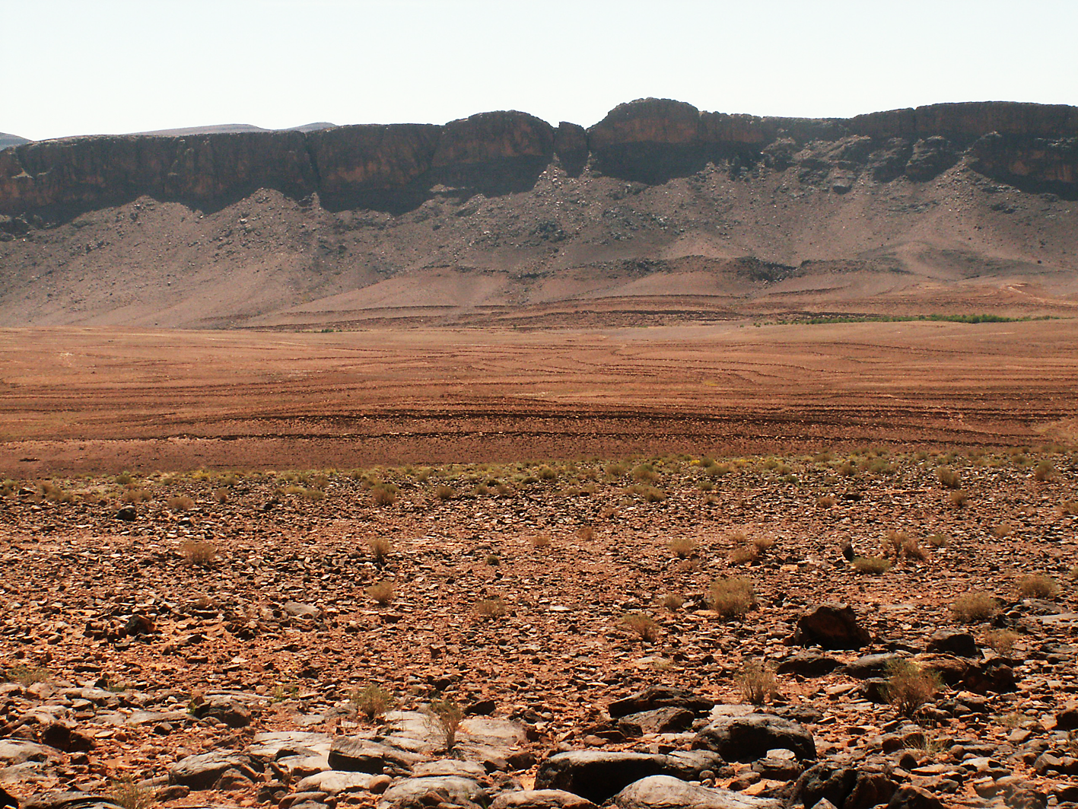
Steep mountain front with reg plain, near Zagora

A characteristic assemblage of landforms occurs in the Piedmont Zone
- a steep mountain front or scarp below which is a debris slope littered with boulders released by block disintegration
- a knick-point, or piedmont angle, between the mountain front and the extensive pediment
- gorges may dissect the mountain front, eroded by vertical erosion, below which are alluvial fans, or bajadas, deposited by streams where they issue onto the pediment surface
- playas (ephemeral lakes) or salinas may also occur at some distance from the mountain front. Sand dune deposits may also occur on the pediment surface
(Most of these features may be seen in the desert landscapes around Ouarzazate and Zagora)
A Pediment is a remarkably smooth bedrock plain extending in front of desert mountains. There is an abrupt transition between the relatively flat pediment and the steep mountain front. Isolated, steep-sided residuals (inselbergs or mesas) may stand out above the plains. The pediments may be covered by extensive alluvial deposits laid down by sheet and stream floods as rivers emerge from the mountain gorges.
Pediments represent a change in the hydrological character of streams, with dominantly vertical erosion in the mountain gorges and aggradation through the deposition of alluvium on the pediment. The pediment is a slope of deposition and transportation, over which debris eroded from the mountain front is moved to an area of aggradation. The angle of slope declines away from the mountain front because the debris is finer and therefore a lower angle of slope is needed to move the sediment.
The development of the pediment surface is linked to the recession of the scarp face of the mountain front, which is undergoing parallel slope retreat. Continued recession of the mountain front may leave behind residual hills in the form of mesas and inselbergs.
The surface of the pediment may be covered with coarse debris, forming a reg or desert pavement of loose stones. The removal of sand and dust particles by wind action contributes to the concentration of stones on the pediment surface. The passage of sand across such reg plains causes the gravel and stones to be polished and worn by the wind, forming ventifacts. Many of the rocks on the plains are black or dark brown in colour, having acquired a veneer of iron and manganese rich material: desert varnish.

The work of wind
Because of the lack of moisture and limited vegetation cover wind action is seen as an important process in hot desert environments. However, the importance of wind should not be over-estimated as both wind and water play a significant, but locally varying, part in the development of different types of desert landscape.
The two main processes of wind erosion are deflation and abrasion:
- Deflation occurs when winds blow across a bare desert surface selectively picking up fine sand and silt particles, leaving behind larger sediments to form a pebble-strewn desert pavement, or reg. This can be seen in the diagram below:
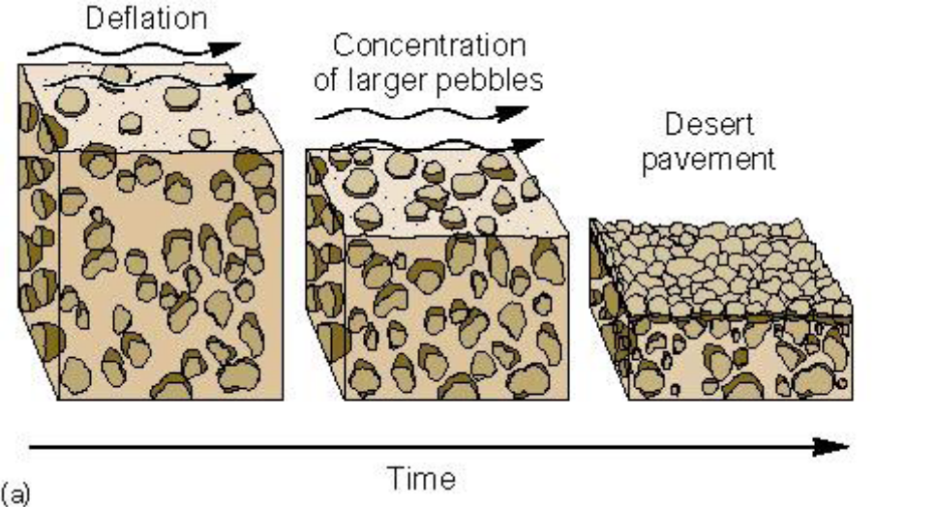
- Abrasion is the sand-blasting effect of sand-laden wind on exposed rock surfaces close to the ground which are smoothed, pitted, polished and worn away. Distinctive landforms produced by abrasion include ventifacts, yardangs and zeugen. Ventifacts can be seen on pebble-strewn desert pavements as individual rocks with sharp edges and smooth sides.
The effects of deflation and abrasion can be seen on the stony desert plains near Zagora.
The processes of transportation of by wind include suspension, saltation, and surface creep, depending on the strength of the wind and particle size of the sediments.
- Very fine sediments can be raised to considerable heights and carried great distances in suspension. This can often give rise to dust storms produced by the deflation of fine materials from desert surfaces, significantly reducing visibility.
- Saltation occurs with larger sand particles which are briefly lifted from the desert surface before returning to the ground. The particles are rarely lifted more than a few centimetres from the desert surface.
- Surface creep is the continuous movement of larger sand particles in strong winds across the desert surface.

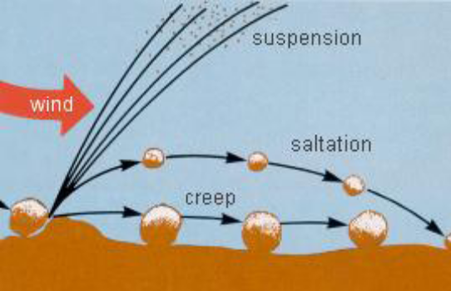

Dust storms occur frequently around Zagora and in strong winds the processes of saltation and surface creep can also be observed.

Sand Dunes
Sand which has been eroded and transported from desert surfaces may be deposited to form accumulations known as sand dunes. A dune field is an area covered by extensive sand dunes; large dune fields are known as ergs. It is estimated that 25% to 30% of the world’s deserts are covered by aeolian sand and large ergs are to be found in the north-west Sahara.
Good examples of sand dunes are rare within the study area, but large dune fields can be seen near Zagora, especially near the Berber camp. The deposition of sand is a problem at Tinfou where fields and buildings have been buried by sand, possibly related to the process of desertification and the removal of vegetation cover from the desert plains by human activity. Most of the sand is believed to be of local origin.
The geometric forms of deposition of sand dunes are very varied and depend on factors such as the supply of sand, the nature of the wind regime, the extent of vegetation cover and the shape of the ground surface.

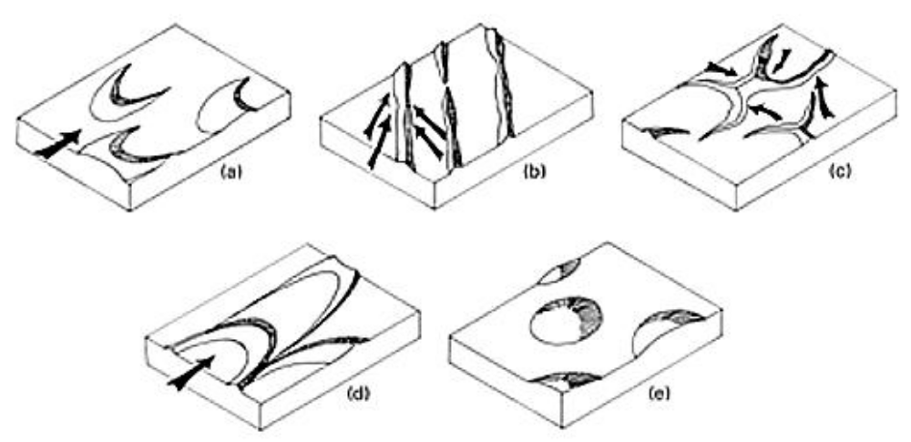
a. barchan or cresentic dune
b. linear or longitudinal dune
c. star dune
d. parabolic dune
e. dome dune
Types of sand dune
In a barchan, wind-blown sand moves up the gentle upwind side of the dune by saltation or creep. Sand accumulates at the crest of the dune; when this exceeds the angle of repose a small avalanche of grains slides down the steep slip face. Grain by grain the dune moves forward.
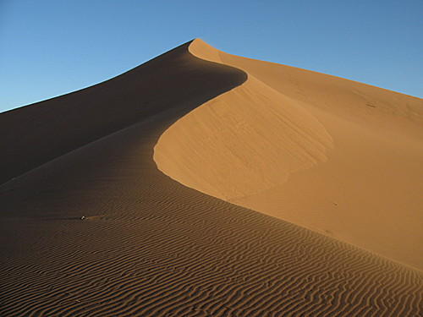 | 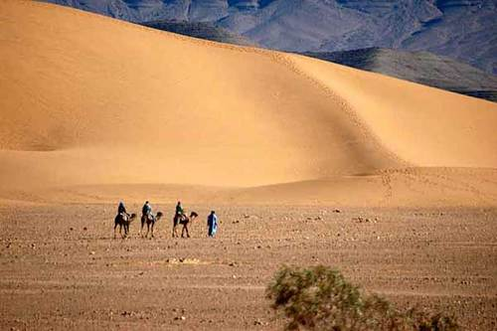
Sand dunes near Zagora

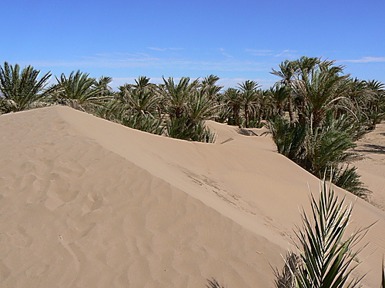
Tinfou: sand dune encroachment onto irrigated fields

activities
The information gathered during the field work can be used for the following activities:
- Why is physical weathering an important process in desert regions?
- Explain the meaning of the following terms:
  - Block disintegration
  - Sheet flood
  - Wadi
  - Mesa
  - Inselberg
  - Reg desert
- Why do some rivers, like the Draa, have a permanent flow?
- With the help of an annotated diagram, outline the processes which are responsible for the type of desert landscape shown below:
Explain the processes resulting in parallel slope retreat
- With the help of annotated diagrams, explain the formation of the following landforms:
  - Barchan
  - Wadi
  - Gorge
  - Mesa
  - Alluvial fan
- For the landscape to the west of Ouarzazate, or the landscape around Zagora:
Describe the main features of the landscape and explain how wind and running water have contributed to its formation.

Arid Environments Observers Game…
To help keep you awake during the long drive to the desert, we have designed a game for you, based on the old ‘Observers books’ of the 1930’s to 1970’s. You will need to know your desert landscape features and processes and be able to spot them in the real world!
For every arid environment landscape feature or process spotted, you will score the number of points indicated (the points reflect how difficult to find the various things are). Tick each one when you have seen it and double your points if you can get a photograph. Good luck.

For one point:
Sand dune
Desert varnish
Deflation hollow
Reg desert
Erg desert
Mesa
Desert pavement
Wadi
Piedmont

For two points:
Crescent dune
Linear dune
Exfoliation
Butte
Evidence of an ephemeral stream
Pediment
Saltation
Alluvial fan
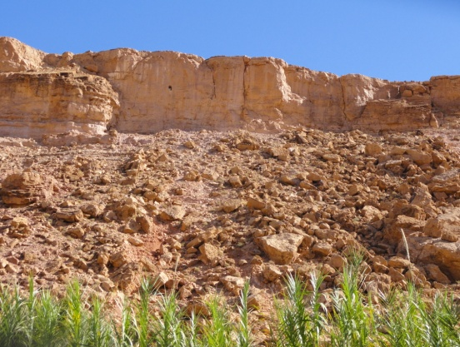

For three points:
Mushroom rocks
Vetifact
Brading
Salination
Block disintegration
Cap stone
Desert canyon
Surface creep
Bahadas
Suspension (look out for a dust storm!)

Block disintegration between Ouarzazate and Tizi- n-Tichka.

